Project Compassion 2025
School Newsletter Notices

Throughout Lent, we encourage schools to promote Caritas Australia’s Project Compassion in their weekly newsletter and by sharing content on their social media platform as a way of informing parents and the wider community about our Lenten appeal.
Need additional resources such as logos, high-resolution photos, or more details?
Please email us at: projectcompassion@caritas.org.au
IMPORTANT: The QR codes included in the Newsletter notices below, will direct the scanner to the Caritas Australia website to make a donation directly to Project Compassion. If you would like to track the donations received from your school community - you can sign your school up for an online fundraising page where you can download a unique QR code for your school. You will then be able to track the donations received by your community. To find out more and to register your school page, please visit: https://fundraise.projectcompassion.org.au/schools

*Please note: Photos provided are strictly for use in connection with Caritas Australia’s Project Compassion 2025 campaign.
Photo credits:
- Toefuata’iga’s Story - Samoa – Caritas Australia
- Lam’s Story – Vietnam - Caritas Australia
- Irene’s Story – DRC - Arlette Bashizi/Caritas Australia

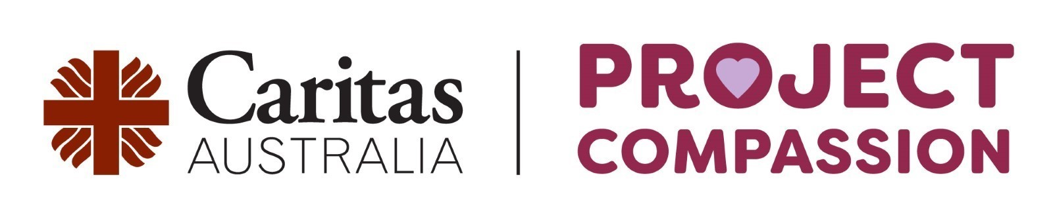

Ash Wednesday
(5th of March 2025)
This Lent, we are called to Unite Against Poverty through Caritas Australia’s Project Compassion. By taking home a Project Compassion donation box or envelope, you’ll be answering the Gospels’ call to care for our global family and walk alongside the most vulnerable.
Your generous support this Lenten Season will enable Caritas Australia to provide life-changing support to communities facing poverty, food insecurity, lack of education, and water shortages, while building resilience against future challenges. Together, through faith and action, we can bring hope and opportunity to those most in need.
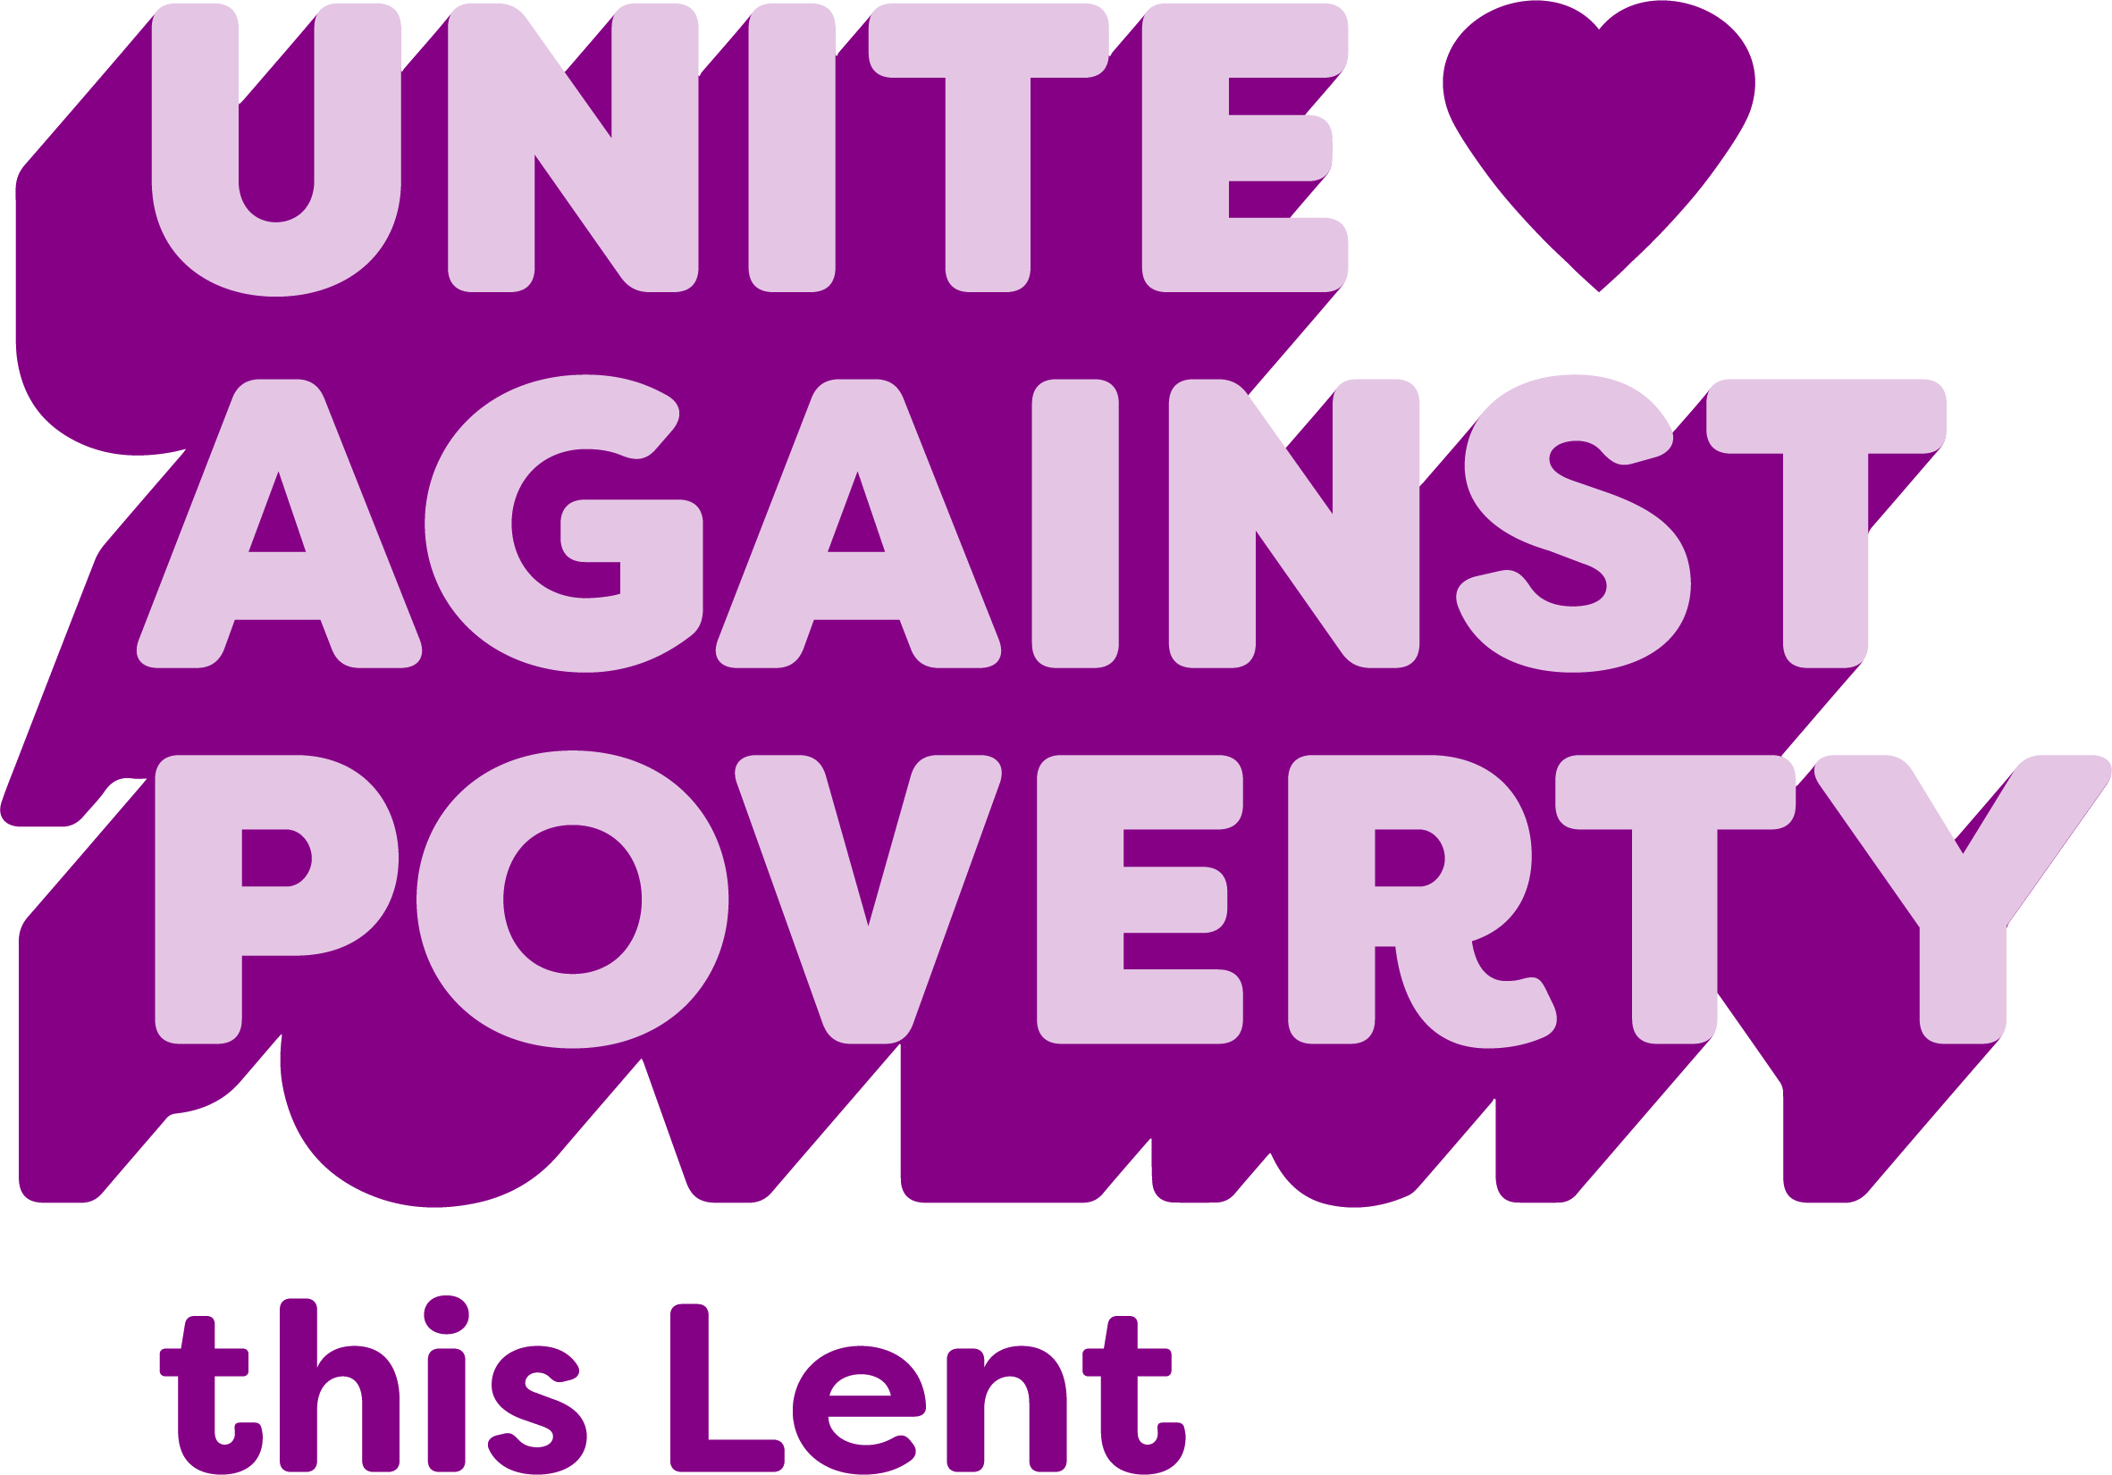
Please donate today.
You can support Project Compassion 2025 through the donation boxes, envelopes or by scanning the QR code above.
Or online at: caritas.org.au/project-compassion
Or by calling: 1800 024 413
Thank you for standing with us, as we Unite Against Poverty this Lent.

First Week of Lent
(Week beginning Monday 10 March)
This Lent, we’re invited to Unite Against Poverty with Caritas Australia’s Project Compassion. This year is especially significant as we celebrate the Jubilee Year - a time of renewal and solidarity.
Project Compassion 2025 shares three stories from around the world. We’ll meet Toefuata'iga - (Toy-foo-ah-tah-ing-ah) a young student from Samoa who faced severe water shortages at her school. Thanks to Caritas Australia and the generosity of supporters like you, her school now has a 10,000 L water tank improving hygiene and allowing the teachers to prioritise education.
We’ll get to know Lam from Vietnam, born with short stature, Lam faced social exclusion and limited employment opportunities – through the I-SHINE program, Lam is now a freelance graphic designer.
And we’ll meet Irene from the Democratic Republic of the Congo (DRC) who faced immense challenges after losing her father to war and raising her children in poverty. With support from Caritas Australia, Irene received vocational training in sewing and farming and can now support her whole family.
Watch our Introduction to Project Compassion film HERE - be inspired by 3 powerful stories of resilience and strength, and learn the impact that your support can have on vulnerable communities around the world.

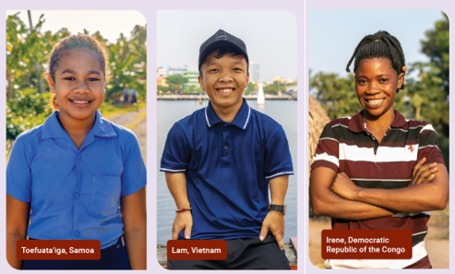
Please donate today.
You can support Project Compassion 2025 through the donation boxes, envelopes or by scanning the QR code above.
Or online at: caritas.org.au/project-compassion
Or by calling: 1800 024 413
Thank you for standing with us, as we Unite Against Poverty this Lent.

Second Week of Lent
(Week beginning Monday 17 March)
Toefuata'iga - (Toy-foo-ah-tah-ing-ah) is a 13-year-old primary school student from Samoa. Samoa may be a country surrounded by water, but access to clean drinking water is scarce in some areas, with many families facing extreme hardship as a result.
Toefuata’iga’s school community struggled without reliable access to clean water, which impacted students’ education and hygiene. Teachers often had to leave the school to fetch water from nearby homes, disrupting lessons and adding strain to the community. When the water ran out at the school, students were sent home which meant they missed out on valuable learning time.
Thanks to the support of Caritas Australia in partnership with Caritas Samoa, Toefuata’iga’s school now has a 10,000 L water tank through a Water, Sanitation, and Hygiene (WASH) program. Teachers and students are now able to focus on education and improved hygiene.
“Now that we have the water tank, things are so much better, we can stay at school all day, and I get to spend more time learning and playing with my friends. I’m happy that we don’t have to go home early anymore.” – said Toefuata'iga.
This transformative story is just one example of how Caritas Australia’s Project Compassion creates waves of change around the world.
Watch Toefuata'iga’s story here.
Will you stand with students like Toefuata'iga this Lent?

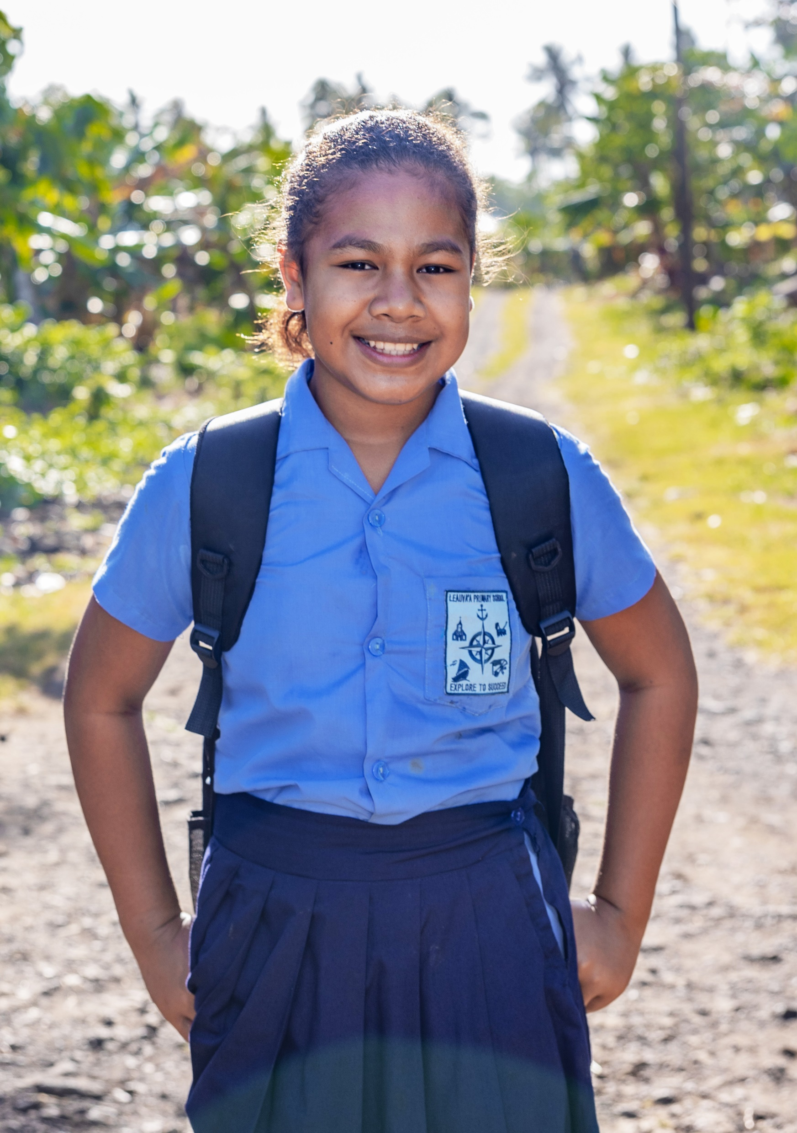
Photo credit: Caritas Australia
Please donate today.
You can support Project Compassion 2025 through the donation boxes, envelopes or by scanning the QR code above.
Or online at: caritas.org.au/project-compassion
Or by calling: 1800 024 413
Thank you for standing with us, as we Unite Against Poverty this Lent.

Third Week of Lent
(Week beginning Monday 24 March)
Lam is 27 years old from a small village in rural Vietnam who faced significant challenges due to his short stature. Growing up, Lam often felt isolated due to limited job opportunities and difficulty moving around his community. While his friends started jobs after high school, Lam stayed home with his parents, unsure if he could ever achieve his dream of becoming a graphic designer.
Everything changed when Lam joined the I-SHINE program, supported by Caritas Australia. Through this initiative, Lam completed a six-month course developing his graphic design skills. Along the way, he built confidence, made friends and gained a sense of connection.
Today, Lam runs a successful freelance graphic design business from home, serving clients worldwide and earning a steady income. Lam hopes his story will encourage other young people with disabilities to overcome obstacles and pursue their dreams.
Lam’s journey shows how your support of Project Compassion empowers individuals to break barriers and transform their lives.
Watch Lam’s story here
Will you walk alongside people like Lam this Lent?
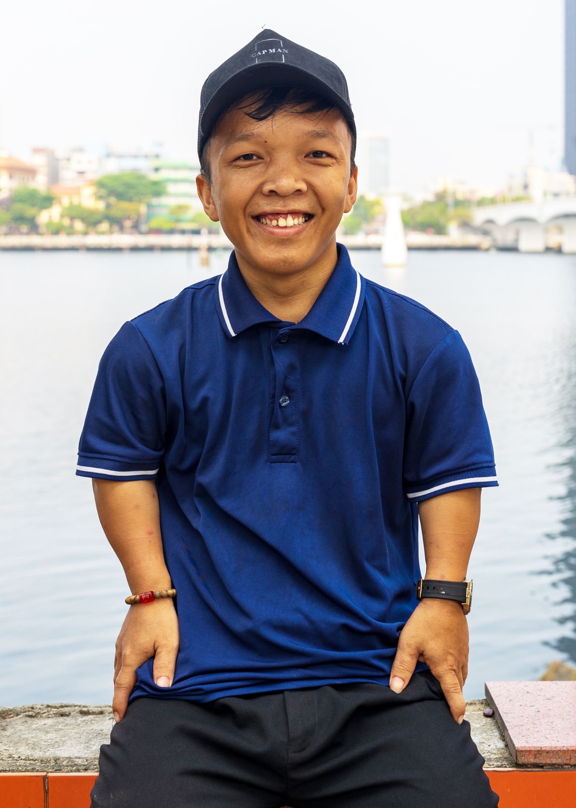
Photo credit: Caritas Australia
Please donate today.
You can support Project Compassion 2025 through the donation boxes, envelopes or by scanning the QR code above.
Or online at: caritas.org.au/project-compassion
Or by calling: 1800 024 413
Thank you for standing with us, as we Unite Against Poverty this Lent.

Fourth Week of Lent
(Week beginning Monday 31 March)
Irene lives in a remote village in the Kongolo Region in the Democratic Republic of the Congo (DRC).
Life hasn’t been easy for Irene. After losing her father in a war, Irene and her family were forced to flee their home. Life became even more challenging when her husband left, leaving Irene to raise her 2 children alone. Without finishing her education and with few job opportunities in her village, she struggled to provide even the basics for her family.
Things began to change when Irene joined the Youth Capacity Strengthening Program (YCSP), run by Caritas Kongolo with the support of Caritas Australia. Through the program, Irene learned sewing skills and was provided with a sewing machine and fabric. Irene also gained farming skills. Now, she grows enough food to feed her family and even shares her sewing knowledge by mentoring other women in her community.
“Before, women depended on men's income, but now, with our sewing skills, we can take care of ourselves,” Irene said.
Your support of Project Compassion helps women like Irene to create brighter futures for themselves and their families.

Watch Irene’s story here. (For secondary students and parents)

Will you stand in solidarity with people like Irene this Lent?
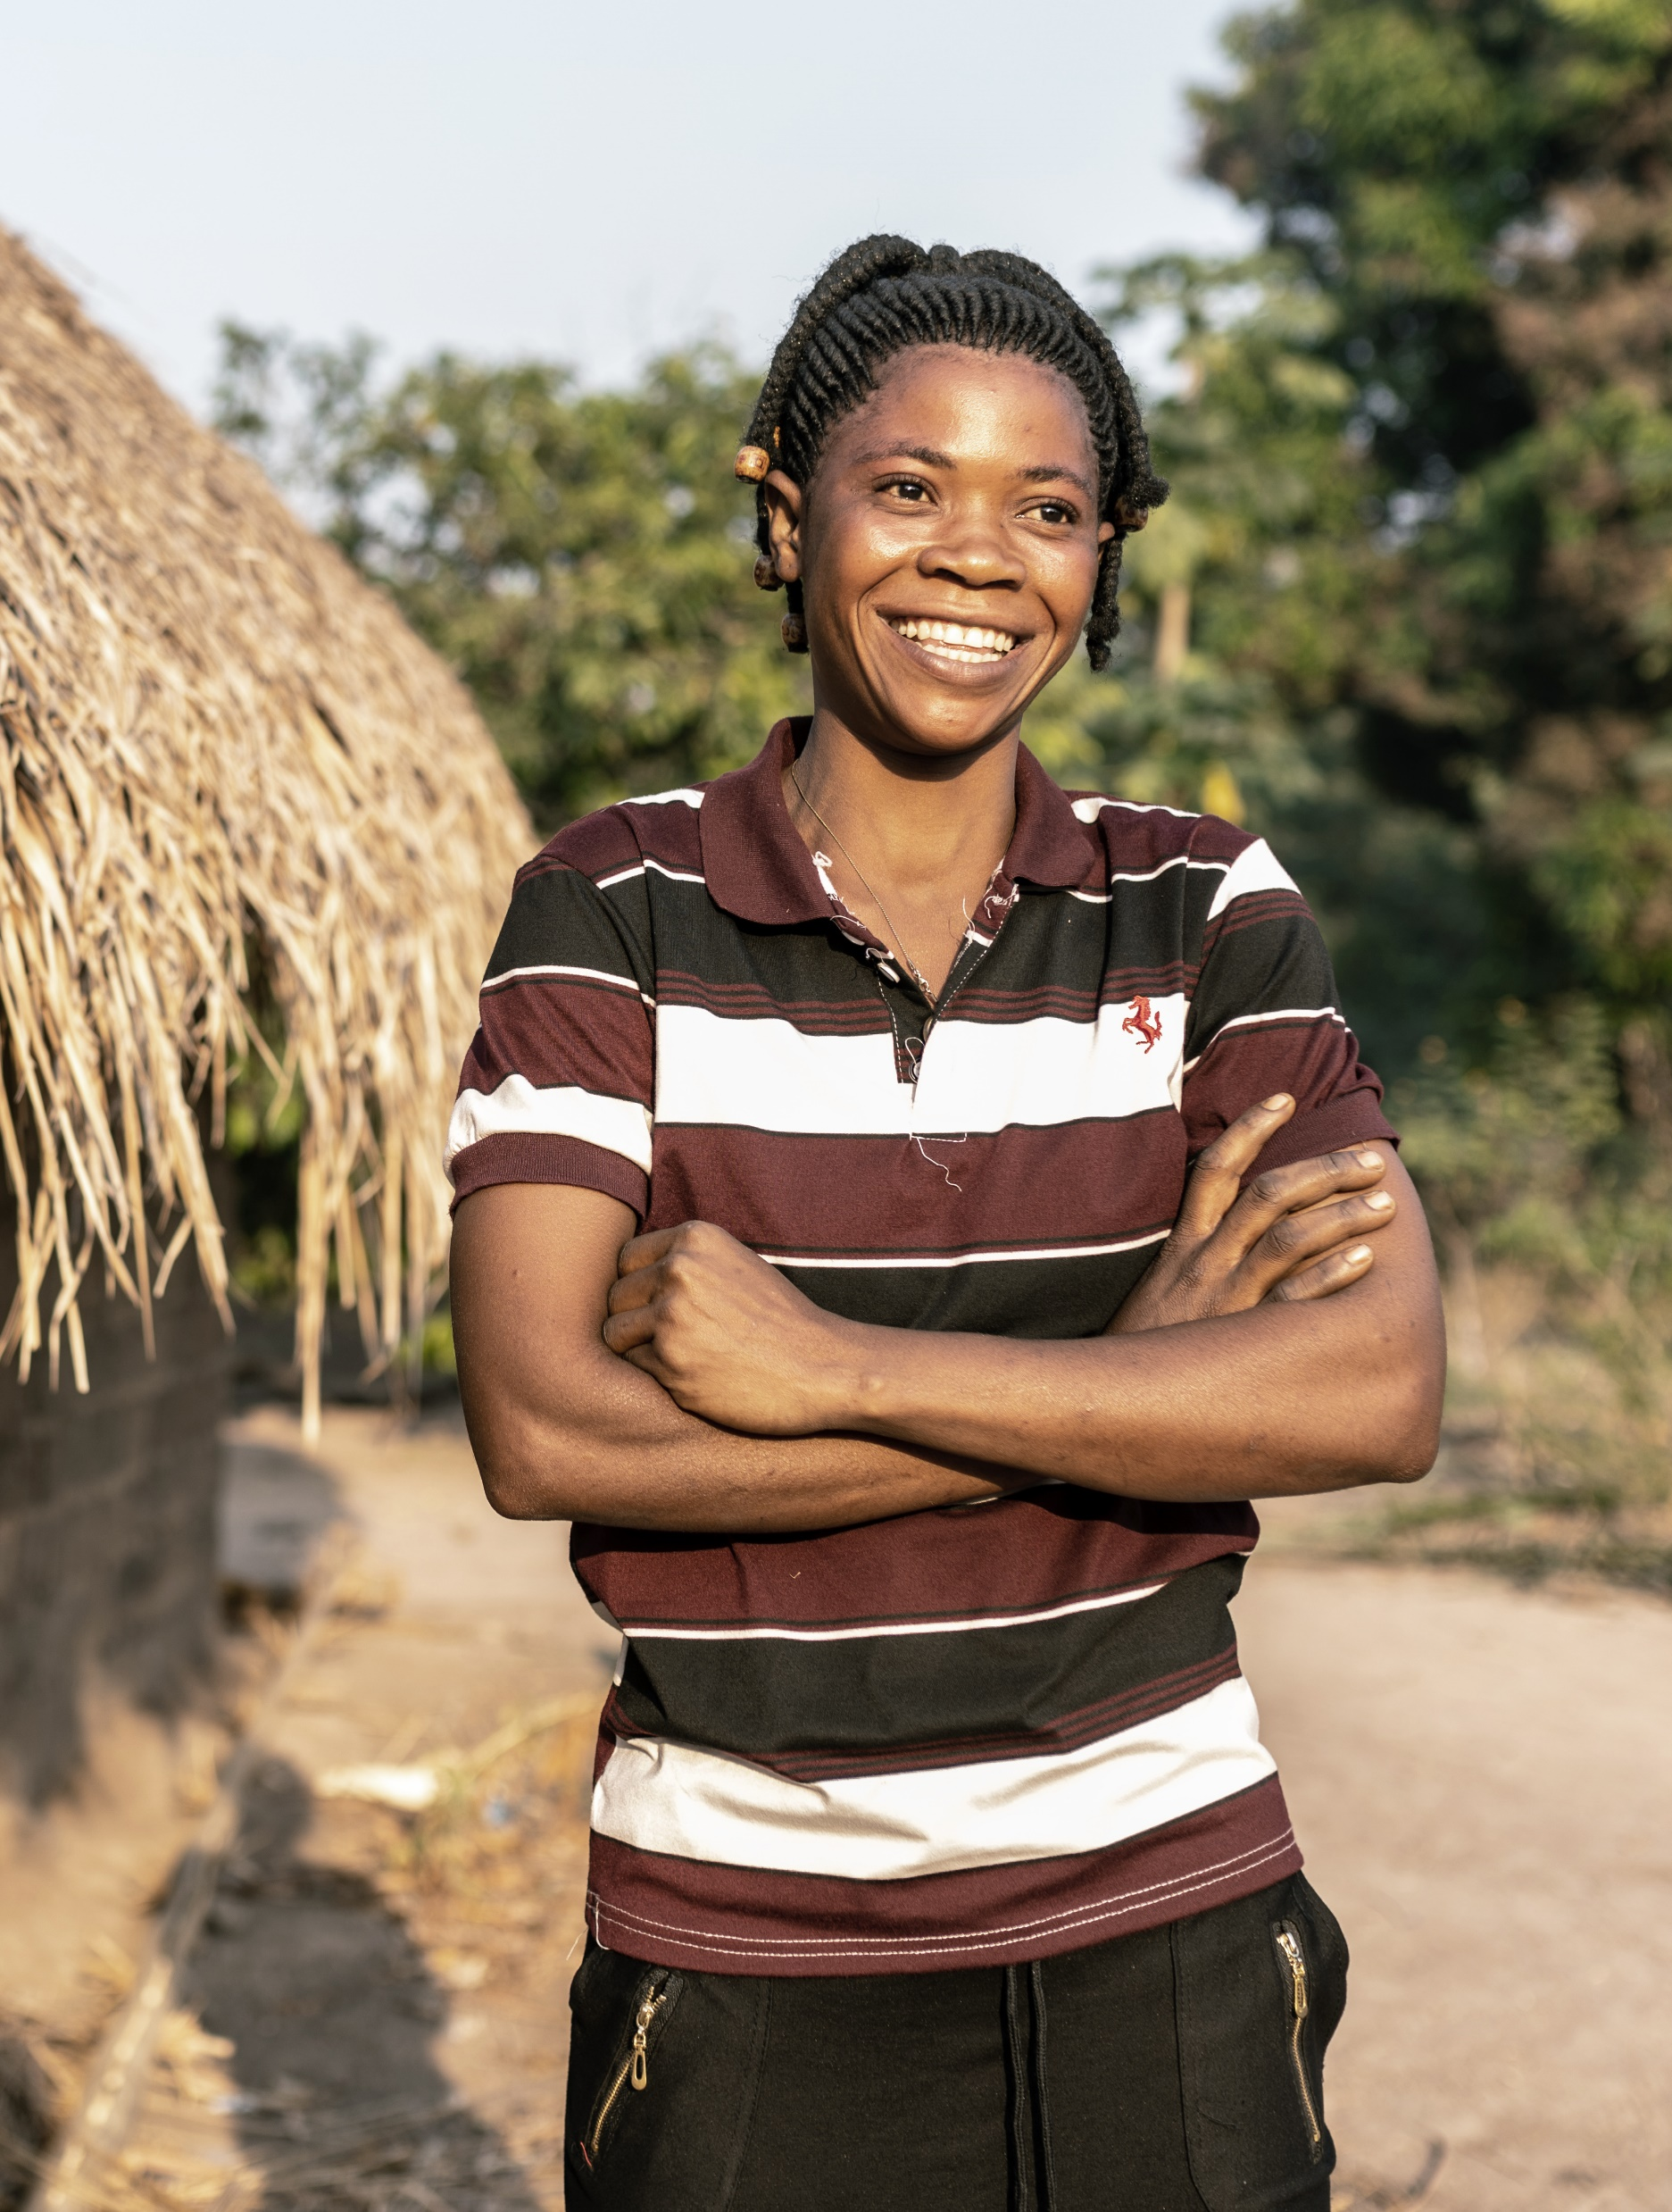
Photo credit: Arlette Bashizi/Caritas Australia
Please donate today.
You can support Project Compassion 2025 through the donation boxes, envelopes or by scanning the QR code above.
Or online at: caritas.org.au/project-compassion
Or by calling: 1800 024 413
Thank you for standing with us, as we Unite Against Poverty this Lent.

Fifth Week of Lent
(Week beginning Monday 7 April)
The transformative work of Caritas Australia is only possible thanks to supporters like you and the dedication, passion, and resilience of our local partners, who tirelessly work to empower communities and create brighter futures.
In Vietnam, Caritas Australia’s partner programs, like I-SHINE, helped Lam, a young man with a disability, gain graphic design skills and start a successful freelance business, inspiring others to pursue their dreams.
In Samoa, Caritas Australia works with Caritas Samoa to improve access to clean water and sanitation through initiatives like water tank installations, transforming health and well-being for families like Toefuata’iga’s.
In the Democratic Republic of the Congo, Caritas Australia works in partnership with Caritas Kongolo on the Youth Capacity Strengthening Program. This initiative equipped Irene, a single mother, with sewing and farming skills, enabling her to support her family and empower others in her community.
Through partnerships like these, Caritas Australia creates lasting change in communities across the globe.

Please donate today.
You can support Project Compassion 2025 through the donation boxes, envelopes or by scanning the QR code above.
Or online at: caritas.org.au/project-compassion
Or by calling: 1800 024 413
Thank you for standing with us, as we Unite Against Poverty this Lent.

Holy Week
(Week beginning Monday 14 April)
This Lent, we shared the powerful stories of three remarkable individuals who have overcome immense challenges. Thanks to the kindness of supporters like you, their lives - and the lives of those around them - have been transformed.
In Samoa, Toefuata'iga’s life was changed with access to clean water through Caritas Australia’s partnership with Caritas Samoa. Her school now has a water tank, improving health and allowing the school to focus on education.
Lam, from rural Vietnam, overcame the challenges of living with a disability by joining the I-SHINE program. He now runs a successful freelance graphic design business and inspires others to pursue their dreams.
In the Democratic Republic of the Congo, Irene, a single mother, found hope through Caritas Australia’s partnership with Caritas Kongolo. By learning sewing and farming skills, she now provides for her extended family and mentors other women in her community.
Thanks to supporters like you, the lives of people like Toefuata'iga, Lam, and Irene have been transformed. But the work isn’t done yet. There is still time to donate! Together, we can Unite Against Poverty and help transform lives this Lent.

It’s not too late to donate.
You can support Project Compassion 2025 through the donation boxes, envelopes or by scanning the QR code above.
Or online at: caritas.org.au/project-compassion
Or by calling: 1800 024 413
Thank you for standing with us, as we Unite Against Poverty this Lent.

Thank you – after easteR
THANK YOU
Caritas Australia would like to express our heartfelt thanks for your incredible support of Project Compassion this Lent.
If you still have your Project Compassion box at home, please bring them back into school next week. Your generosity this Lent is helping to empower the world’s most vulnerable communities, enabling them to overcome challenges and lift themselves out of poverty.
Together, we are creating a better tomorrow, helping vulnerable communities build stronger futures for themselves and empowering them to break free from the cycle of poverty. Thank you for standing with us!
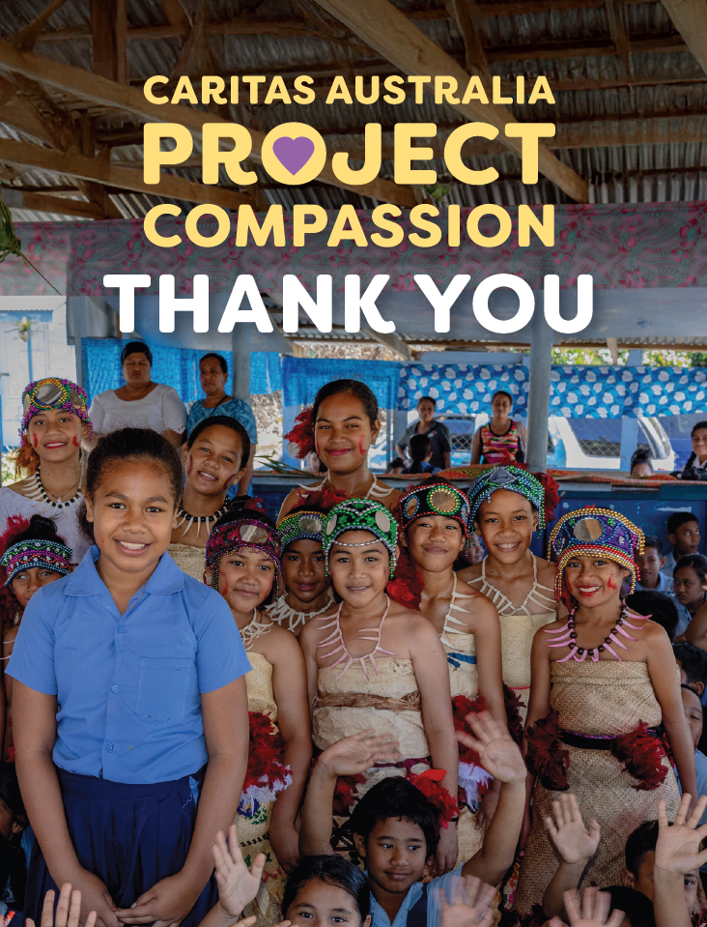
It’s not too late to donate.
You can support Project Compassion 2025 through the donation boxes, envelopes or by scanning the QR code above.
Or online at: caritas.org.au/project-compassion
Or by calling: 1800 024 413
Thank you for standing with us, as we Unite Against Poverty this Lent.

