**Lenten Weekly Reflections**

*Written by Michael McGirr*

**projectcompassion.org.au**

**Ash Wednesday**

We pray this Lent for a deeper trust in God’s plan. May our commitment to prayer, fasting and almsgiving, awaken within us a hunger for justice and compassion. May the Jubilee year remind us of our need for a fresh start. May our work for Project Compassion help us to *Unite Against Poverty*.

**Prayer of Intercession**

Photo: Toefuata’iga (13) smiles as she reads a dictionary in a Samoan primary school. Credit: Caritas Australia.

There is a great story about G K Chesterton, the famous writer who died in 1936. Among many things, he was the creator of Fr Brown, the detective who uses powers of empathy to understand people better than the police. He was once asked to contribute an essay to a collection on the theme of ‘What is Wrong with the World?’ His response to the question required only two words. ‘I am,’ he wrote.

Ash Wednesday, which celebrates the start of Lent, calls us to a more courageous engagement with reality. That is why, when we receive ashes, we often hear the words ‘remember you are dust and to dust you will return.’ That is our truth. It is easy to look at the state of the world and descend into blame and indignation.

Sure, there are many things that are desperately troubling. Wars, poverty and environmental degradation are part of a long list. But who among us has the courage to own up and respond to the question, ‘what’s wrong with the world,’ by answering ‘I am.’

Don’t misunderstand. We are mostly good people, doing our best to love and serve each other. But we would sell ourselves short if we left the future of Earth to others who we thought were more to blame. Ash Wednesday asks us to look at the world and our part in it. Every year, we begin our journey to Easter with Jesus’s advice to go into our private room, wherever that may be, and encounter the Lord one on one. Christianity, unlike so much else in the world, has little time for self-marketing.

Ash Wednesday is Day One of our Lenten journey. God’s invitation to ‘come back to me with all your heart’ is also an invitation to leave our private room and step into a world in urgent need of our love and honesty. This year, Project Compassion is calling us to *Unite Against Poverty*. St Paul says, ‘now is the favourable time.’ We can make the most difference when we are most truly ourselves.

**Joel 2:12–18 | Ps 50:3–6. 12–14. 17. R. v.3 | 2 Corinthians 5:20–6:2 | Matthew 6:1–6. 16–18**

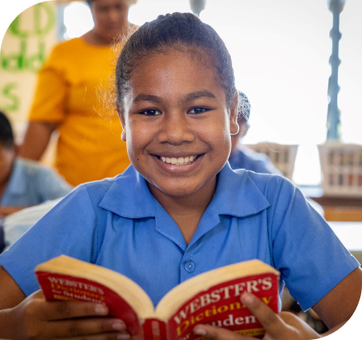

We pray for greater respect for the environment. May we care deeply for Earth, the place that God has entrusted to our care. May we celebrate the Year of Jubilee year as pilgrims of hope, ready to find the direction towards peace and justice that God wants for us. May we *Unite Against Poverty* as we grow in respect for all life.

**Prayer of Intercession**

Photo: Samoan primary school students dance during their lunch break. Credit: Caritas Australia.

The desert plays a significant part in Scripture: it is a place of both discovery and of getting lost. You may recall that Moses encountered God in the wilderness when he hears a voice from the burning bush.

He discovered something vital to us all that day: God points us in a direction we may not choose for ourselves. Later, however, Moses and his people are lost in the desert for 40 years. We read the finale of that story in today’s first reading.

First Australians have also had an intimate connection with the desert. Many Indigenous cultures danced in time with the desert for countless generations. When the so-called Pintupi Nine made ‘first contact’ after emerging from the Gibson Desert in 1984, they were in excellent health. The same desert could kill Europeans in thirty-six hours or less.

In today’s Gospel, we learn that the Spirit led Jesus to a lonely place. Up to this point in Luke’s Gospel, we have seen Jesus as a member of his family and community. We have met Mary and Joseph and Elizabeth and Simeon and Anna and John the Baptist. Now Jesus must stand on his own and decide what really matters in life. Is he going to rely on material things? Is he going to want power at any price? Is he going to put himself rather than God at the heart of his decision making? These are the temptations of the devil.

Lent presents us with the same choice. Are we going to find our direction or just be lost in the swirling confusion of choices with which life presents us? Project Compassion helps us to find direction by offering us the opportunity to *Unite Against Poverty*. Are we content for the world to become more and more fragmented. Or would we prefer to stand up against voices of opportunism and exploitation? Every year, Caritas Australia is overwhelmed and grateful that our Catholic communities are so clearly on the side of justice and life.

**First Sunday of Lent**

**Deuteronomy 26:4–10 | Ps 90:1–2. 10–15. R. v.15 | Romans 10:8–13 | Luke 4:–13**

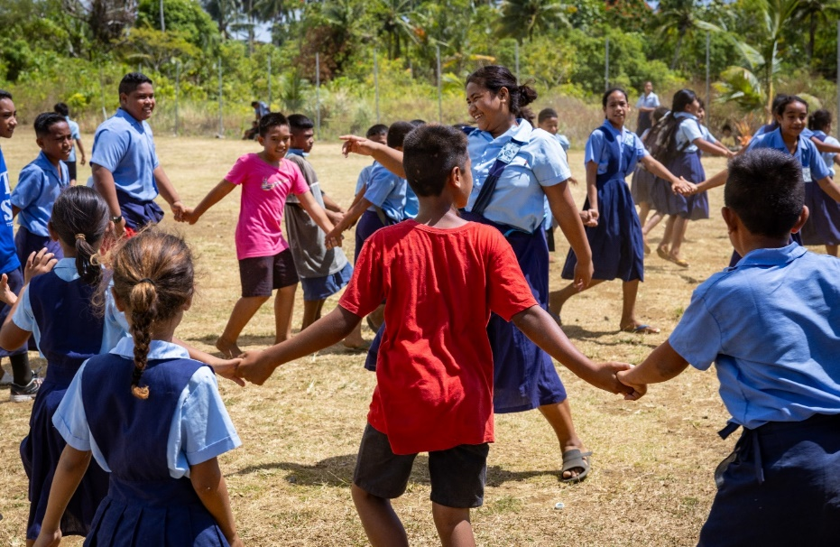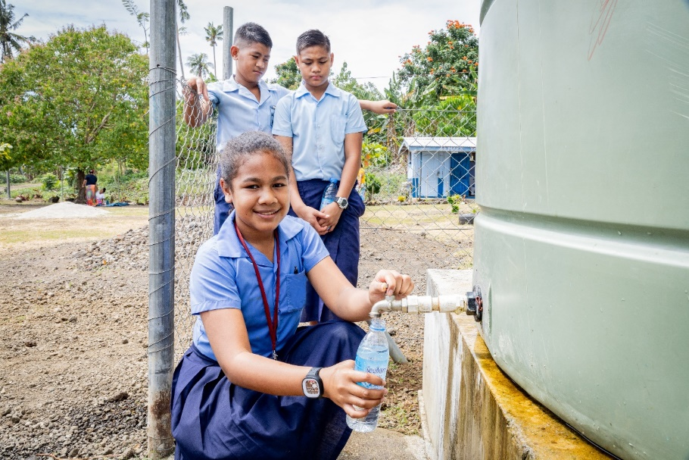

**Prayer of Intercession**

We pray for all those whose access to food and water is insecure. May the whole human family respond generously in creating lasting justice in the distribution of life’s necessities. May we respond to opportunities such as those presented by Project Compassion this Lent to *Unite Against Poverty*. May we all be one.

**Second Sunday of Lent**

Photo: Toefuata’iga (13) fills up her water bottle from a Samoan primary school’s water tank. Credit: Caritas Australia.

Today’s Gospel brings us a wonderful moment in the education of Jesus’s friends.

Jesus was always trying to teach them about the mystery of life, and we can take heart from the fact that they were often slow learners. Peter, James and John see Jesus transfigured on the top of a mountain. But the vision doesn’t last long. Peter, always practical, wants to build tents so they can stay in the moment. But no, the journey to Calvary lies ahead where they will see Jesus disfigured. Eventually, they will put it together that transfiguration and disfigurement are two sides of the same coin.

This week, Caritas Australia’s Project Compassion shares another story of education. We visit a primary school in Samoa with 400 students and 11 teachers. Until 2023, the school had no reliable access to fresh water. At times, teachers had to fetch water from neighbouring families, and this took considerable time out of the day and limited classes. It also meant that each class had a single bucket of drinking water for everyone to share. Thanks to your generosity, this has now changed.

Education can continue uninterrupted. You might even say, that thanks to those who support Project Compassion, disfigured lives have been transfigured.

Samoa may seem a long way away but let us think for a moment of some of the words Jesus said on the night before he died. He prayed ‘may they all be one.’ We see the high price of division and conflict in so many places. People face each other with such hostility. As we Unite Against Poverty, we are slowly creating the solution. Our actions are teaching the world to see possibilities more than problems. Just as his friends saw Jesus in a brilliant new light, so too must we see the whole human family with its true dignity.

**Genesis 15:5–12. 17–18 | Ps 26:1. 7–9. 13–14. R. v.1 | Philippians 3:17 – 4:1 | Luke 9:28–36**

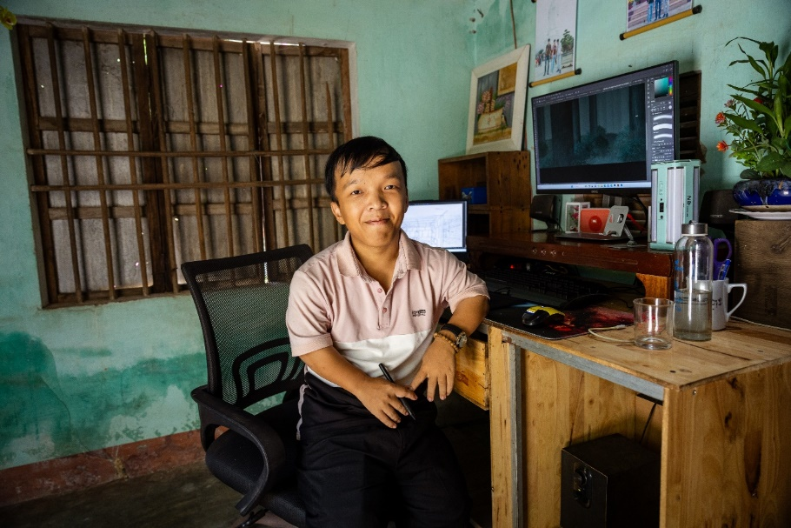

We pray for anyone who lives with disability, especially people who are stigmatised in any way. May we do all we can to support their flourishing as truly equal participants in the human family. May our work this Lent with Project Compassion help to create greater justice.

**Prayer of Intercession**

Photo: Lam is working as a freelance Graphic Designer from his home in Quang Nam, Vietnam. Credit: Caritas Australia

Sometimes you hear Indigenous people refer to Jesus as a ‘person of Country’. What might this mean?

It is hard to imagine the Gospels without the connection of Jesus to the sea, the river, the desert, the fields and the mountain. His teaching often featured seeds and birds and sheep and corn. In today’s Gospel, we hear the parable of the fig tree. The impatient person wants to cut it down. A wiser person is prepared to work with nature by putting manure on the tree and looking after it. This is a story of growth. God is creative. God is patient with us. God gives us another chance. He journeys with us on our pilgrimage of hope.

This week, Project Compassion brings us the story of Lam, a young man from rural Vietnam. Lam’s disability made his upbringing difficult. Sometimes people look at those with disability a little like the fig tree. They judge them and dismiss them.

Through the I-SHINE program, supported by Caritas Australia’s partner in Vietnam, Catholic Relief Services (CRS), Lam was able to pursue his dreams and become more independent. He enrolled in a six-month IT Technician training course in Da Nang that not only equipped him with professional skills but also rekindled his social connections and confidence. Lam’s dedication during the training paid off as he launched a freelance graphic design business from his home. Today, he is a successful graphic designer, serving clients locally and internationally and earning a stable income every month. He has a creative life.

In today’s reading, Moses is in the wilderness, a place of surprising possibilities. Like the Australian landscape, the wilderness in Scripture is subtle; it is a place of encounter with God. Moses thinks he is having a regular day in the family business, looking after his father-in-law’s sheep. But a voice comes from a bush that is blazing without being burnt up. The voice tells Moses to take off his shoes because ‘the place on which you stand is holy ground.’ This is the beginning of the freedom story of his people, the start of their journey out of captivity. May we *Unite Against Poverty* as we create a better world for all God’s people.

**Third Sunday of Lent**

**Exodus 3:1–8. 13–15 | Ps 102:1–4. 6–8. 11. R. v.8 | 1 Corinthians 10:1–6, 10–12 | Luke 13:1–9**

**Fourth Sunday of Lent**

Photo: Irene teaches other women how to sew after participating in the Caritas-supported youth empowerment program in the Democratic Republic of the Congo. Credit: Arlette Bashizi/Caritas Australia

One of the most beautiful expressions in the Bible comes from the prophet Ezekiel (Ezk 11:19). ‘Thus says the Lord, I will take their hearts of stone and give them hearts of flesh.’ It is a call to be tender and compassionate.

You would need a heart of stone not to be affected by the stories we encounter today. Most of us have heard the story of the two sons in today’s Gospel over and over. The brilliance of the way Jesus tells stories is that it still gets under our skin. Here are two young men who think they can live on their own terms. One has a sense of entitlement and demands his share of his father’s estate which he then squanders. He is finally prepared to eat humble pie and find his way home. The other son has a different sense of entitlement. He believes that his hard work and reliability should provide him with a greater share of his father’s love. At different times in our life, we can relate more to one or other of these people. Jesus implies that they are both blind to the way God’s love works and that they both need to grow. They have both been dead and now must come to life.

The story we encounter this week is also deeply moving. Irene, aged 25, lives in the Kongolo region in the Democratic Republic of the Congo. Her father was killed during a war and Irene lived with her mother on very meagre resources, often going hungry for extended periods of time. Irene first became pregnant as a teenager and later had to raise her two children on her own, with the support of her mother. As a single mother, it was challenging for Irene to care for her two sons without a stable income.

Irene’s life changed after she participated in the Youth Capacity Strengthening program, run by Caritas Australia’s partner, Caritas Kongolo. Through the program, she undertook training in sewing and livestock farming, enabling her to generate income to support her family.

Our second reading today reminds us that we are ‘ambassadors for Christ.’ St Paul says, ‘for anyone who is in Christ, there is a new creation.’ Let us all be part of building that new creation, setting the world to rights as best we can. Our part is to reach out in compassion and love to heal the wounds of the whole human family. Let us all Unite Against Poverty as pilgrims of hope in this Year of Jubilee.

**Joshua 5:9–12 | Ps 33:2–7. R. v.9 | 2 Corinthians 5:17–21 | Luke 15:1–3. 11–32**

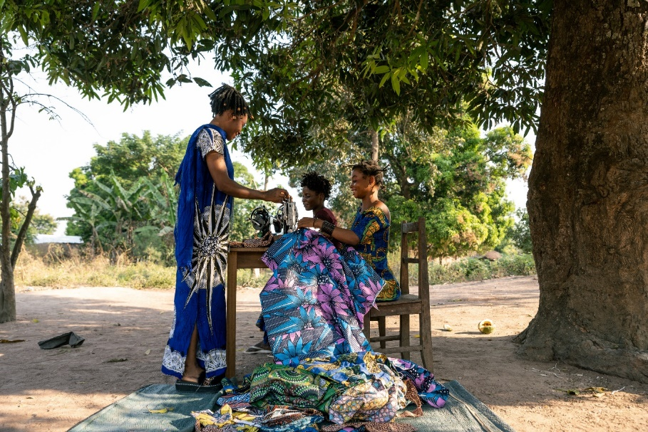

We pray for those driven away from their homes by violence, persecution or poverty, especially women. May our hearts be open to do all we can to rebuild the lives of others through supporting Caritas Australia and the work of Project Compassion. May we be instruments of God’s peace and pilgrims of hope.

**Prayer of Intercession**

**Fifth Sunday of Lent**

**Isaiah 43:16–21 | Ps 125. R. v.3 | Philippians 3:8–14 | John 8:1–11**

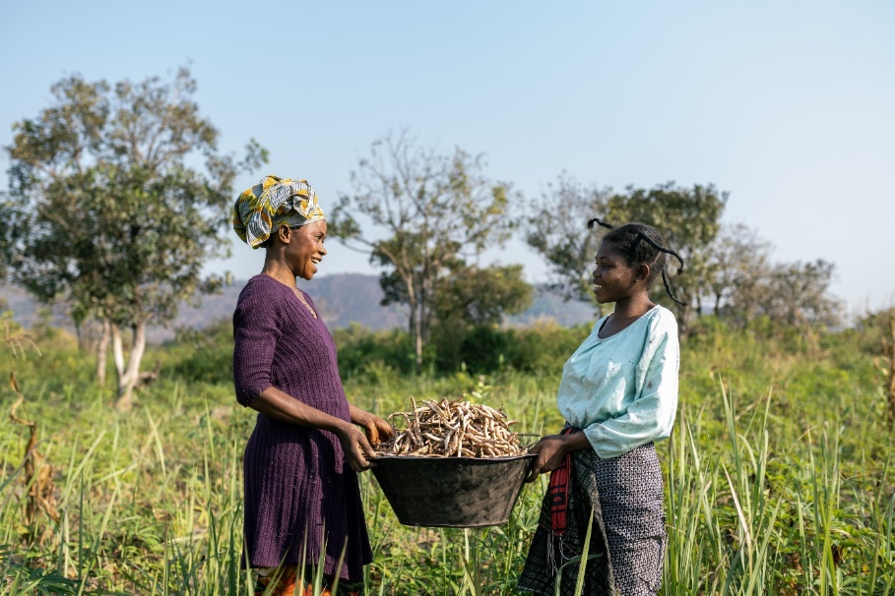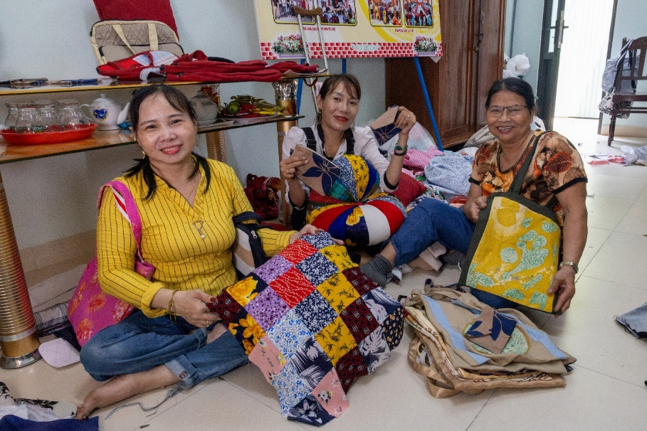

Photo: Irene and her niece harvest vegetables in the Democratic Republic of the Congo. Credit: Arlette Bashizi/Caritas Australia

Pope Francis has spoken a great deal about our need for more women to occupy positions of leadership, both in the Church and in the world at large.

In his wonderful letter about the way we belong to each other, Fratelli Tutti, he says ‘the organization of societies worldwide is still far from reflecting clearly that women possess the same dignity and identical rights as men. We say one thing with words, but our decisions and reality tell another story.’ He is concerned about ‘those women who endure situations of exclusion, mistreatment and violence’.

Pope Francis very much reflects the attitude of Jesus whose closeness to women distinguished him as a leader and teacher in his time. You might think of significant encounters in the New Testament: the woman at the well, Martha and Mary, the widow of Nain. You might also think of the woman we met in today’s Gospel, described by the scribes and Pharisees as ‘caught in the very act of committing adultery.’ Listen to the sneer in those words.

These men, who are supposed to be educated and respected, have been peeping through the window. Their behavior is salacious, domineering and demeaning. In their self-righteousness, they threaten violence. There is no sign of the woman’s partner who is surely just as much part of the story. Jesus neatly turns the tables.

He starts by sitting on the ground, occupying a position lower than that of the woman. He is the only one not taking an eyeful of her. Caritas Australia, whom we support through Project Compassion, has long acted in constructive ways to uphold the dignity of women and honor their strength, resilience and leadership. We have seen this during Lent, particularly in the stories of Irene from the Democratic Republic of the Congo, and Toefuata’iga from a school in Samoa. Please look at Caritas Australia’s resources online; you will find many such stories. In so much of the world, development is led by women.

This Lent, we have also been mindful of the Year of Jubilee, a significant call to Unite Against Poverty as pilgrims of hope. Today’s second reading reminds us that none of us is perfect. But like St Paul, we are still running, still trying to achieve ‘the perfection that comes through faith in Christ.’ This does not mean judging others as the scribes and Pharisees did. It means challenging ourselves to bring the world closer together as Jesus prayed ‘may they all be one.’

We pray that all women may be respected and encouraged to take their rightful place in society. We pray also that all people will have access to clean water and safe housing. May we *Unite Against Poverty* as we act for justice in concrete ways, such as through Project Compassion.

**Prayer of Intercession**

Photo: Participants with a disability are displaying their textile work at the I-SHINE program in Vietnam. Credit: Caritas Australia

**Isaiah 50:4–7 | Ps 21:8–9. 17–20. 23–24. R. v.2 | Philippians 2:6–11 | Luke 22:14 – 23:56 or Luke 23:1–49**

**Palm Sunday**

We pray for a renewal of our faith during Holy Week. May we learn more deeply what it means to be pilgrims of hope in this Year of Jubilee. Through works such as Project Compassion, may we *Unite Against Poverty* and walk alongside our sisters and brothers towards the new life of Easter.

**Prayer of Intercession**

Today we read The Passion narrative from the Gospel of St Luke. It is not by any means for the fainthearted. Even if it is familiar to us, we should try to remember how extraordinary it is.

After so many centuries of cruelty, crucifixion still ranks as one of the most appalling things people have ever thought to do to their fellow humans. Yet this was how God chose to show the depth of his love. God was prepared to go to any lengths for us. The letter to the Philippians says that Jesus did not cling to his equality with God but emptied himself to assume the condition of a slave. Why? The only possible explanation is love. Anyone who has loved another knows that it will inevitably bring a share of suffering. Jesus walks alongside all who suffer. He shares their cross as they share his.

The fact that crucifixion was so common in the Roman world should also make us pause for a moment. Jesus lived and died in a world in which people were routinely degraded. He met plenty of them in his travels, people cast by the wayside, and helped many. For those without power, life was fragile, even cheap. Has much changed? Throughout Lent, Caritas Australia has invited us to share the work of Project Compassion. The stories we have encountered remind us that the world is still an uneven field. Project Compassion invites us to respond in love to free people in captivity to very challenging circumstances. It invites us in a small way to carry the cross, to live in hope of the Resurrection.

Perhaps this week, as well as joining in the services of Holy Week, we can take some time to sit quietly with The Passion narrative from Luke’s Gospel on our own. Think about all the characters we meet: Peter, Judas, Pilate, Herod, the women of Jerusalem, Simon of Cyrene, the soldiers, the two criminals, the women from Galilee, the centurion, Joseph of Arimathea. Try to see the events from each of their perspectives. Then quietly see them from your own perspective, from your world in 2025. Pray in humble gratitude.