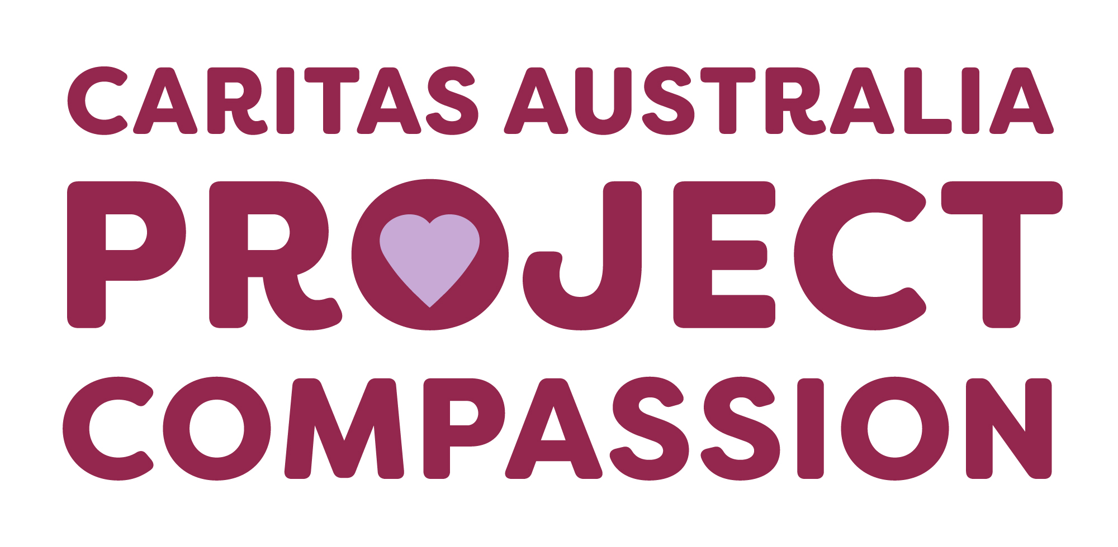

Project Compassion 2025

Parish Bulletin Notices

Throughout Lent, we kindly encourage parishes to promote Caritas Australia’s Project Compassion by sharing weekly bulletin notices with your parishioners and sharing content on your social media platforms to amplify the message of our Lenten appeal.
Need additional resources such as logos, high-resolution photos, or more details?
Please email us at - projectcompassion@caritas.org.au
Each weekly bulletin notice includes two versions: a short summary for limited space and a longer version.
Important Note: The QR codes included in the bulletin notices below, will direct the scanner to the Caritas Australia website to make a donation directly to Project Compassion. If you would like to track the donations received from your parish community - you can sign your parish up for an online fundraising page where you can download a unique QR code for your parish. You will then be able to track the donations received by your community. To find out more and to register your parish page, please visit: https://fundraise.projectcompassion.org.au/parish

*Please note: Photos provided are strictly for use in connection with Caritas Australia’s Project Compassion 2025 campaign.
Photo credits:
- Toefuata’iga’s Story - Samoa – Caritas Australia
- Lam’s Story – Vietnam - Caritas Australia
- Irene’s Story – DRC - Arlette Bashizi/Caritas Australia

Long Version Summary Version
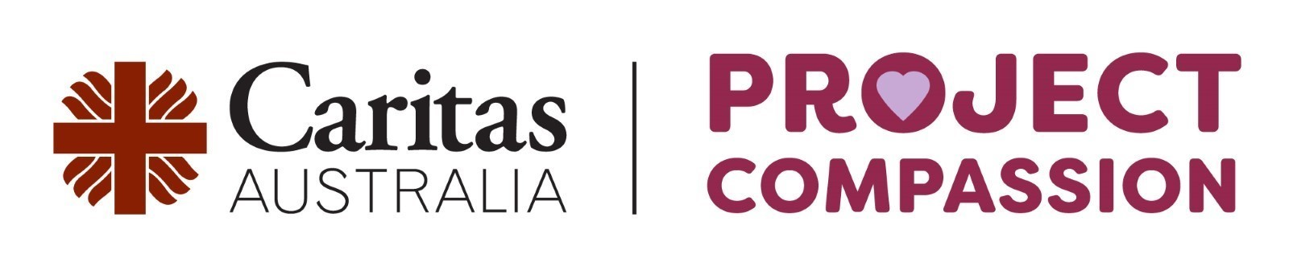
Project Compassion Sunday
1st and 2nd of March 2025

This Lent, we are called to Unite Against Poverty through Caritas Australia’s Project Compassion.
Your generous support this Lenten Season will enable Caritas Australia to provide life-changing support to vulnerable communities in need. 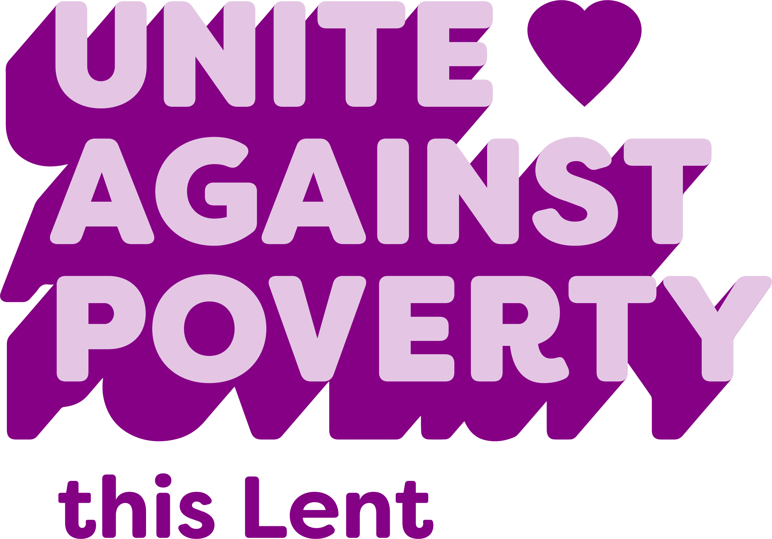
Please donate today.
You can support Project Compassion 2025 through the donation boxes, envelopes or by scanning the QR code above.
Or online at: caritas.org.au/project-compassion
Or by calling: 1800 024 413
Thank you for standing with us, as we Unite Against Poverty this Lent.
Project Compassion Sunday
1st and 2nd of March 2025

This Lent, we are called to Unite Against Poverty through Caritas Australia’s Project Compassion. By taking home a Project Compassion donation box or envelope, you’ll be answering the Gospels’ call to care for our global family and walk alongside the most vulnerable.
Your generous support this Lenten season will enable Caritas Australia to provide life-changing support to communities facing poverty, food insecurity, lack of education, and water shortages, while building resilience against future challenges. Together, through faith and action, we can bring compassion and opportunity to those most in need.
Please donate today.
You can support Project Compassion 2025 through the donation boxes, envelopes or by scanning the QR code above.
Or online at: caritas.org.au/project-compassion
Or by calling: 1800 024 413
Thank you for standing with us, as we Unite Against Poverty this Lent.

Long Version Summary Version
First Sunday of Lent
8th and 9th of March 2025

This Lent, we’re invited to Unite Against Poverty with Caritas Australia’s Project Compassion. This year is especially significant as we celebrate the Jubilee Year - a time of renewal and solidarity.
Project Compassion 2025 shares three stories from around the world. We’ll meet Toefuata'iga - (Toy-foo-ah-tah-ing-ah) a young student from Samoa who faced severe water shortages at her school. Thanks to Caritas Australia and the generosity of supporters like you, her school now has a 10,000 L water tank, improving access to clean water and allowing teachers to prioritise education
We’ll get to know Lam from Vietnam. Born with short stature, Lam faced social exclusion and limited employment opportunities. Through the I-SHINE program, Lam completed a course and is now a freelance graphic designer.
And we’ll meet Irene from the Democratic Republic of the Congo (DRC) who faced immense challenges after losing her father to war and raising her children in poverty. With support from Caritas Australia, Irene received vocational training in sewing and farming and can now support her whole family.
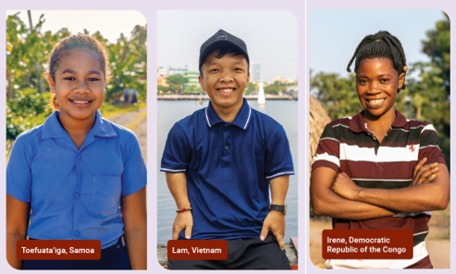
Please donate today.
You can support Project Compassion 2025 through the donation boxes, envelopes or by scanning the QR code above.
Or online at: caritas.org.au/project-compassion
Or by calling: 1800 024 413
First Sunday of Lent
8th and 9th of March 2025

Project Compassion 2025 shares three stories from around the world. We’ll meet Toefuata'iga - (Toy-foo-ah-tah-ing-ah) from Samoa, Lam from Vietnam and Irene from the Democratic Republic of the Congo (DRC).
Each of this year's stories reflects diverse challenges, yet they are united by the shared determination to overcome adversity and create better futures for themselves and their communities.
Please donate today.
You can support Project Compassion 2025 through the donation boxes, envelopes or by scanning the QR code above.
Or online at: caritas.org.au/project-compassion
Or by calling: 1800 024 413

Long Version Summary Version
Second Sunday of Lent
15th and 16th of March 2025

Toefuata'iga - (Toy-foo-ah-tah-ing-ah) a primary school student from Samoa faced severe water shortages at her school. Thanks to Caritas Australia and the generosity of supporters like you, her primary school now has a 10,000 L water tank. Teachers and students now have access to clean drinking water at their school and are able to focus on education.

 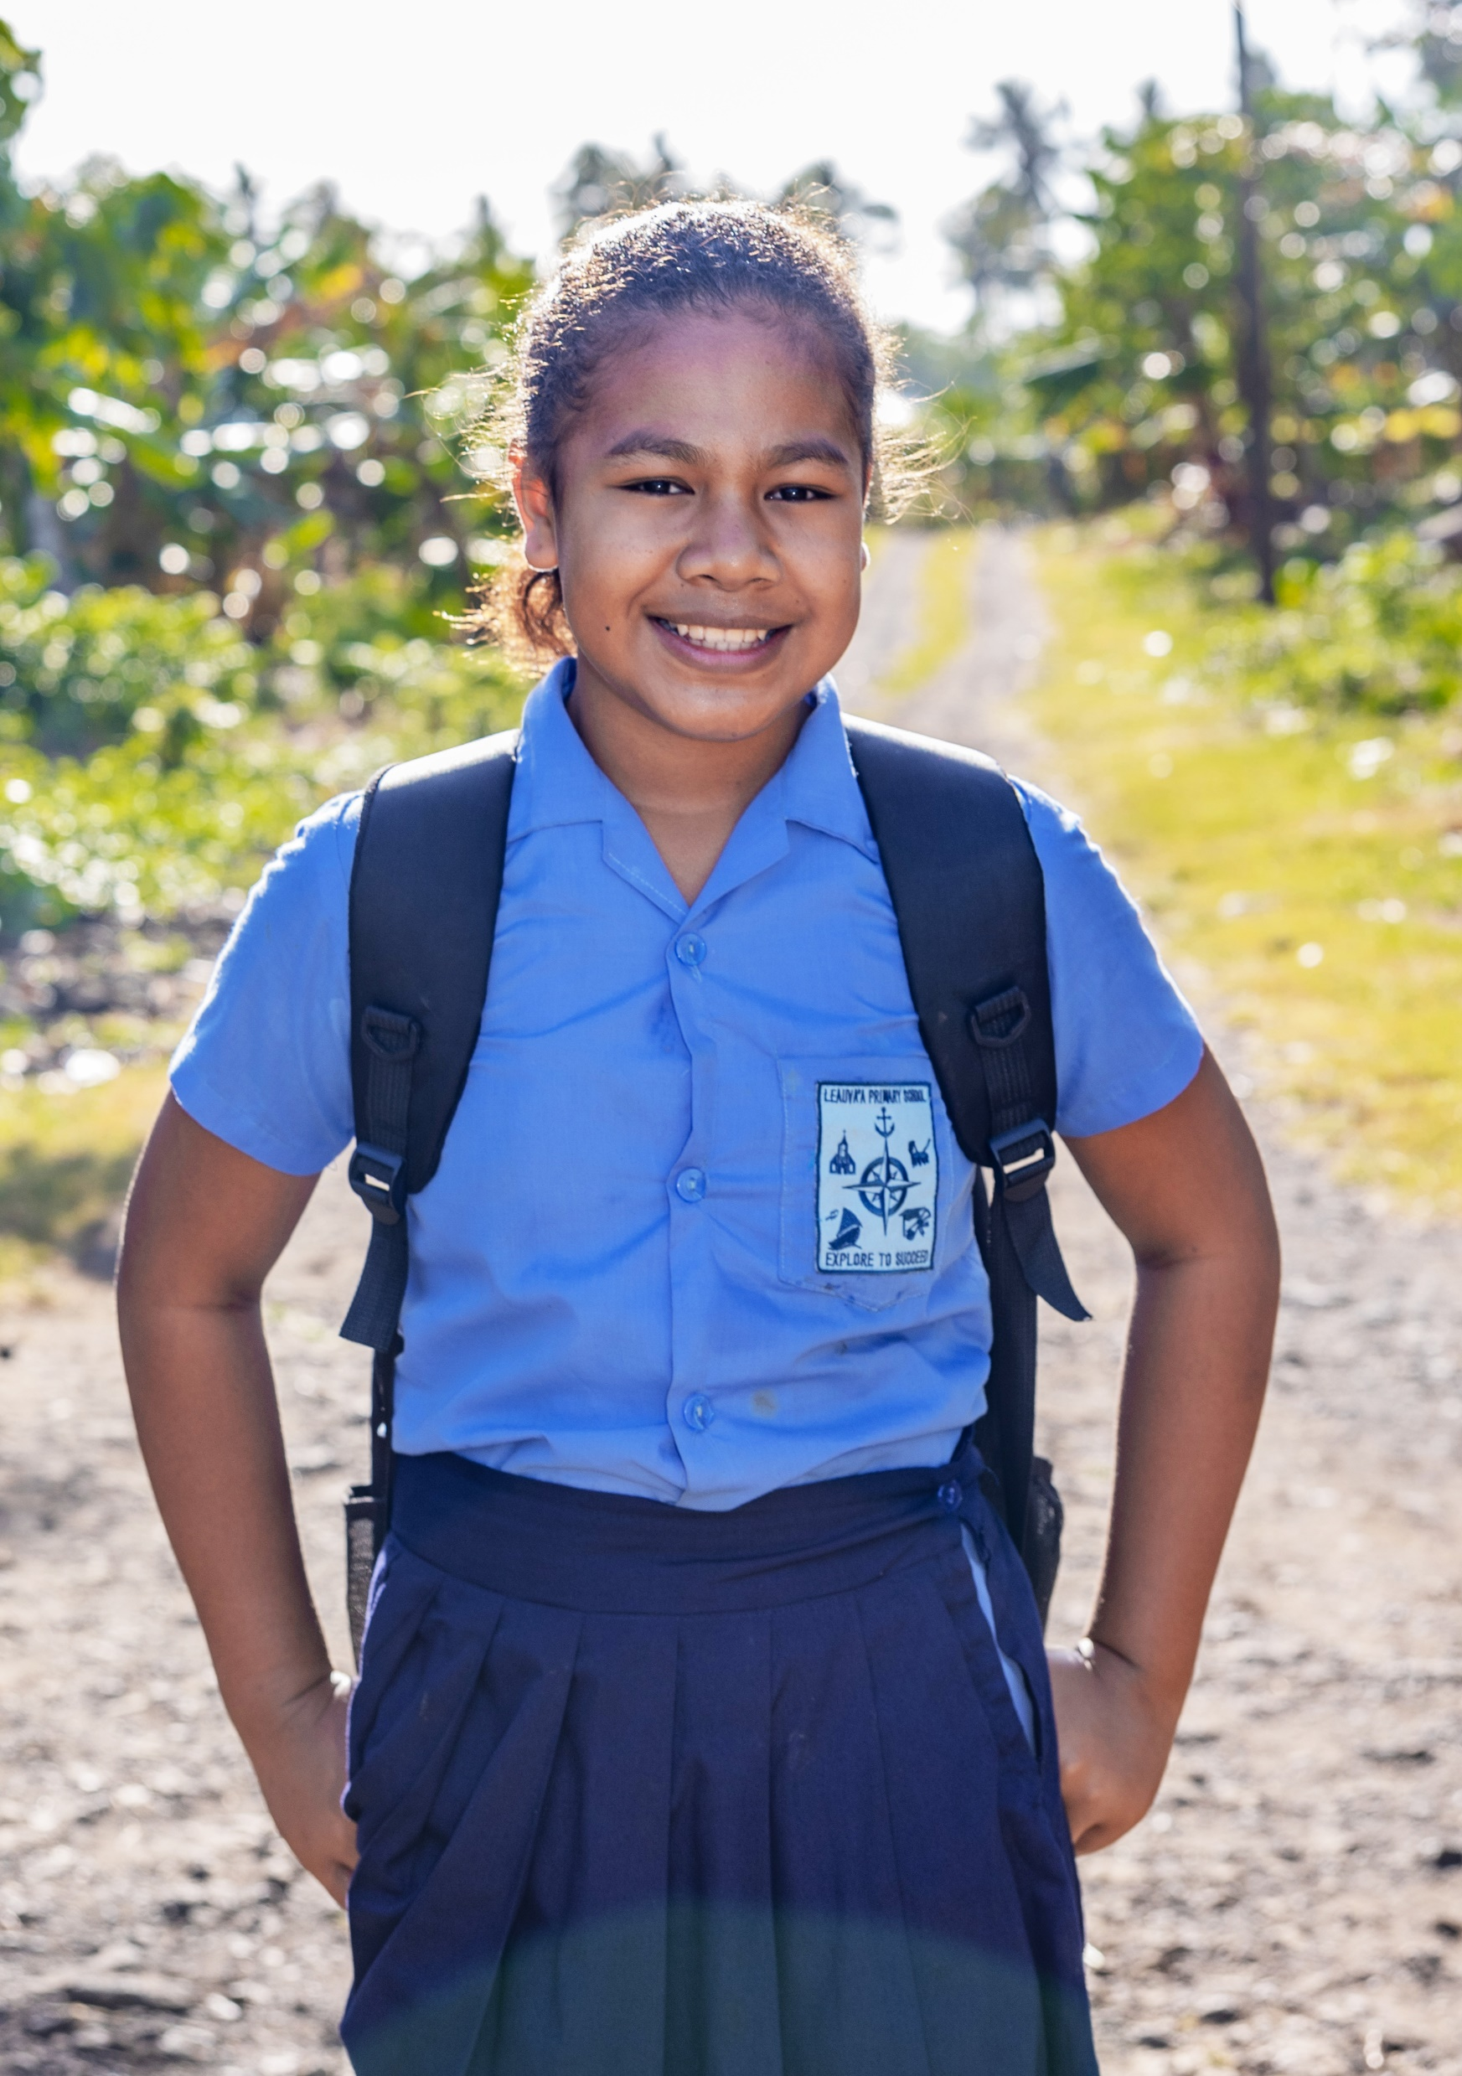
Photo credit: Caritas Australia
Please donate today.
You can support Project Compassion 2025 through the donation boxes, envelopes or by scanning the QR code above.
Or online at: caritas.org.au/project-compassion
Or by calling: 1800 024 413

Second Sunday of Lent
15th and 16th of March 2025

Toefuata'iga - (Toy-foo-ah-tah-ing-ah) is a 13-year-old primary school student from Samoa. Samoa may be a country surrounded by water, but access to clean drinking water is scarce in some areas, with many families facing extreme hardship as a result.
Toefuata’iga’s school community struggled without reliable access to clean water, which impacted students’ education and hygiene. Teachers often had to leave the school to fetch water from nearby homes, disrupting lessons and adding strain to the community. When the water ran out at the school. students were sent home which meant they missed out on valuable learning time.
Thanks to the support of Caritas Australia in partnership with Caritas Samoa, Toefuata’iga’s school now has a 10,000 L water tank through a Water, Sanitation, and Hygiene (WASH) program. Teachers and students now have access to clean drinking water at their school and are able to focus on education.
“Now that we have the water tank, things are so much better, we can stay at school all day, and I get to spend more time learning and playing with my friends. I’m happy that we don’t have to go home early anymore.” – said Toefuata'iga.
This transformative story is just one example of how Caritas Australia’s Project Compassion creates waves of change around the world. Will you stand with students like Toefuata'iga this Lent?
Photo credit: Caritas Australia
Please donate today.
You can support Project Compassion 2025 through the donation boxes, envelopes or by scanning the QR code above.
Or online at: caritas.org.au/project-compassion
Or by calling: 1800 024 413
Thank you for standing with us, as we Unite Against Poverty this Lent.

Long Version Summary Version
Third Sunday of Lent
22nd and 23rd of March 2025

Lam is 27 years old from a small village in rural Vietnam who faced significant challenges due to his short stature. Growing up, Lam often felt isolated due to limited job opportunities and difficulty moving around his community. While his friends started jobs after high school, Lam stayed home with his parents, unsure if he could ever achieve his dream of becoming a graphic designer.
Everything changed when Lam joined the I-SHINE program, supported by Caritas Australia. Through this initiative Lam completed a six-month course developing his graphic design skills. Along the way, he built confidence, made friends and gained a sense of connection.
Today, Lam runs a successful freelance graphic design business from home, serving clients worldwide and earning a steady income. Lam hopes his story will encourage other young people with disabilities to overcome obstacles and pursue their dreams.
Lam’s journey shows how your support of Project Compassion empowers individuals to break barriers and transform their lives.
Will you walk alongside people like Lam this Lent?
 
Photo credit: Caritas Australia
Please donate today.
You can support Project Compassion 2025 through the donation boxes, envelopes or by scanning the QR code above.
Or online at: caritas.org.au/project-compassion
Or by calling: 1800 024 413
Thank you for standing with us, as we Unite Against Poverty this Lent.
Third Sunday of Lent
22nd and 23rd of March 2025

Lam is 27 years old from a small village in rural Vietnam who faced significant challenges due to his short stature. Through the I-SHINE program Lam completed a six-month course developing his graphic design skills. He now runs a successful freelance graphic design business from home, serving clients worldwide and earning a steady income.
Photo credit: Caritas Australia
Please donate today.
You can support Project Compassion 2025 through the donation boxes, envelopes or by scanning the QR code above.
Or online at: caritas.org.au/project-compassion
Or by calling: 1800 024 413 413.

Long Version Summary Version
Fourth Sunday of Lent
29th and 30th of March 2025

Irene lives in the Kongolo Region in the Democratic Republic of the Congo (DRC) and faced immense challenges after losing her father to war and raising her children in poverty. With support from Caritas Australia, Irene received vocational training in sewing and farming and can now support her whole family.
 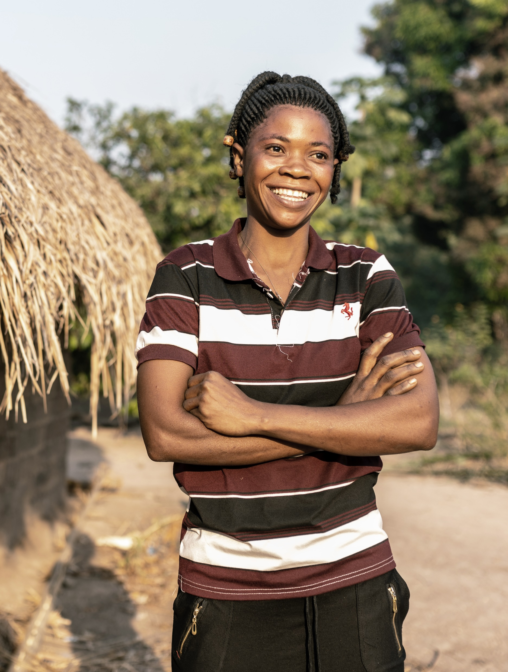
Photo credit: Arlette Bashizi/Caritas Australia
Please donate today.
You can support Project Compassion 2025 through the donation boxes, envelopes or by scanning the QR code above.
Or online at: caritas.org.au/project-compassion
Or by calling: 1800 024 413

Fourth Sunday of Lent
29th and 30th of March 2025

Irene lives in a remote village in the Kongolo Region in the Democratic Republic of the Congo (DRC).
Life hasn’t been easy for Irene. After losing her father in a war, Irene and her family were forced to flee their home. Life became even more challenging when her husband left, leaving Irene to raise her 2 children alone. Without finishing her education and with few job opportunities in her village, she struggled to provide even the basics for her family.
Things began to change when Irene joined the Youth Capacity Strengthening Program (YCSP), run by Caritas Kongolo with the support of Caritas Australia. Through the program, Irene learned sewing skills and was provided with a sewing machine and fabric. Irene also gained farming skills. Now, she grows enough food to feed her family and even shares her sewing knowledge by mentoring other women in her community.
“Before, women depended on men's income, but now, with our sewing skills, we can take care of ourselves,” Irene said.
Your support of Project Compassion helps women like Irene to create brighter futures for themselves and their families.
Photo credit: Arlette Bashizi/Caritas Australia
Please donate today.
You can support Project Compassion 2025 through the donation boxes, envelopes or by scanning the QR code above.
Or online at: caritas.org.au/project-compassion
Or by calling: 1800 024 413
Thank you for standing with us, as we Unite Against Poverty this Lent.

Long Version Summary Version
Fifth Sunday of Lent
5th and 6th of April 2025

The life-changing work of Caritas Australia is only made possible by the unwavering generosity of our supporters and the dedication of our local partners on the ground.
Our partners are the true heroes, working tirelessly on the frontlines every day to transform lives and build brighter, more hopeful futures for their communities.

Please donate today.
You can support Project Compassion 2025 through the donation boxes, envelopes or by scanning the QR code above.
Or online at: caritas.org.au/project-compassion
Or by calling: 1800 024 413

Fifth Sunday of Lent
5th and 6th of April 2025

The transformative work of Caritas Australia is only possible thanks to supporters like you and the dedication, passion, and resilience of our local partners, who tirelessly work to empower communities and create brighter futures.
In Vietnam, Caritas Australia’s partner programs, like I-SHINE, helped Lam, a young man with a disability, gain graphic design skills and start a successful freelance business, inspiring others to pursue their dreams.
In Samoa, Caritas Australia works with Caritas Samoa to improve access to clean water and sanitation through initiatives like water tank installations, transforming health and well-being for families like Toefuata’iga’s.
In the Democratic Republic of the Congo, Caritas Australia partners with Caritas Kongolo on the Youth Capacity Strengthening Program. This initiative equipped Irene, a single mother, with sewing and farming skills, enabling her to support her family and empower others in her community.
Through partnerships like these, Caritas Australia creates lasting change in communities across the globe.
Please donate today.
You can support Project Compassion 2025 through the donation boxes, envelopes or by scanning the QR code above.
Or online at: caritas.org.au/project-compassion
Or by calling: 1800 024 413
Thank you for standing with us, as we Unite Against Poverty this Lent.

Long Version Summary Version
Palm Sunday
12-13th of April 2025

This Lent, we shared the powerful stories of three remarkable individuals who have overcome immense challenges. Thanks to the kindness of supporters like you, their lives - and the lives of those around them - have been transformed.
In Samoa, Toefuata'iga’s life was changed with access to clean water through Caritas Australia’s partnership with Caritas Samoa. Her school now has a water tank, improving health and allowing the school to focus on education.
Lam, from rural Vietnam, overcame the challenges of living with a disability by joining the I-SHINE program. He now runs a successful freelance graphic design business and inspires others to pursue their dreams.
In the Democratic Republic of the Congo, Irene, found hope through Caritas Australia’s partnership with Caritas Kongolo. By learning sewing and farming skills, she now provides for her extended family and mentors other women in her community.
Thanks to the support of your parish community, your generosity will create waves of change around the world. But the work isn’t done yet. There is still time to donate! Together, we can Unite Against Poverty and help transform lives this Lent.
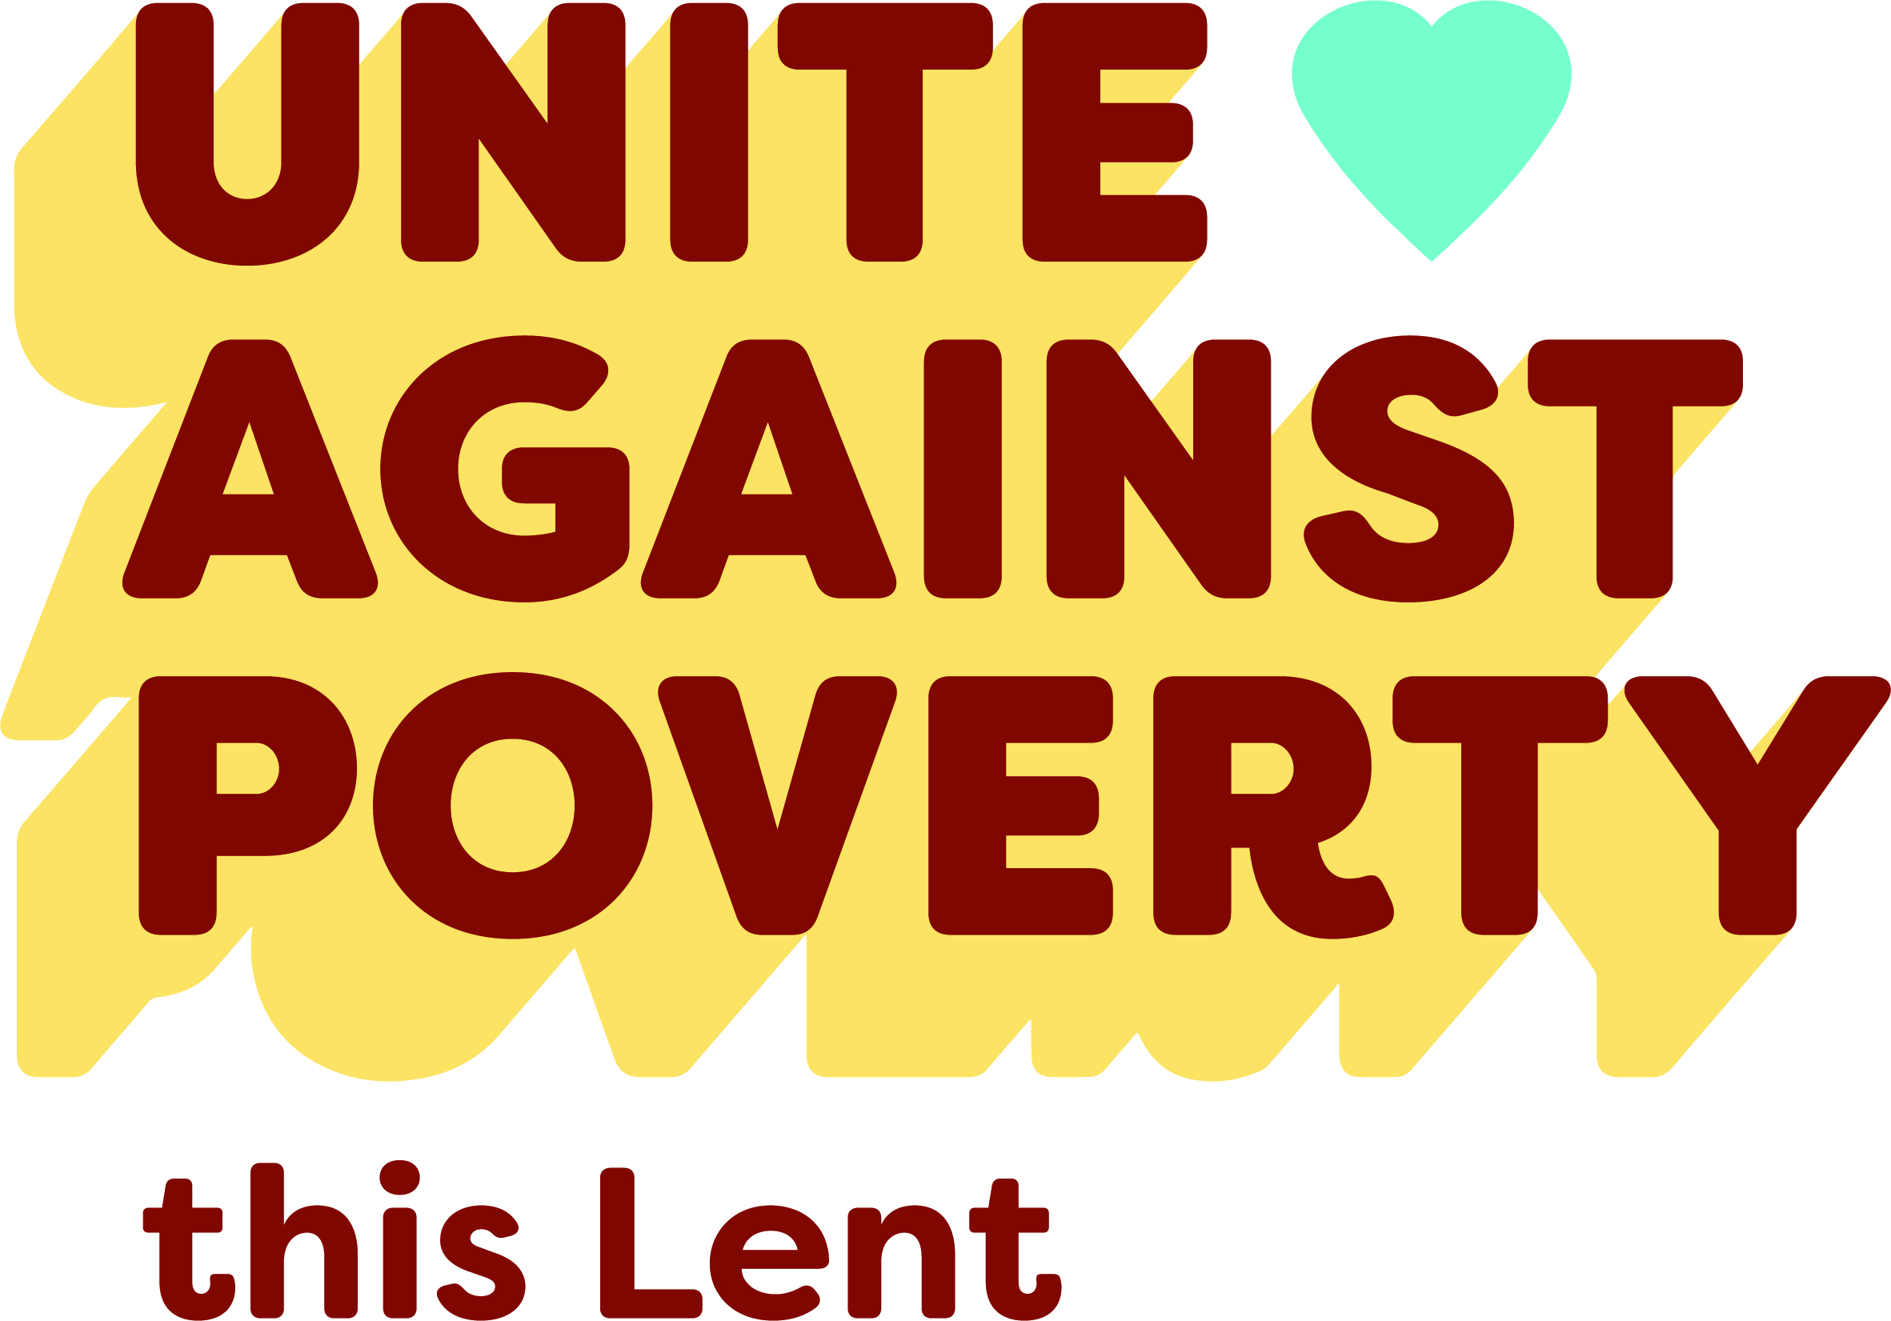
Please donate today.
You can support Project Compassion 2025 through the donation boxes, envelopes or by scanning the QR code above.
Or online at: caritas.org.au/project-compassion
Or by calling: 1800 024 413

Palm Sunday
12-13th of April 2025

As Project Compassion 2025 draws to a close for another year, we want to extend our heartfelt gratitude for your generous support throughout this Lenten Season.
This year, we shared the inspiring stories of 3 individuals whose lives have been transformed through your compassion and generosity.
But the work isn’t done yet. There is still time to donate! Together, we can Unite Against Poverty and help transform lives this Lent.
Please donate today.
You can support Project Compassion 2025 through the donation boxes, envelopes or by scanning the QR code above.
Or online at: caritas.org.au/project-compassion
Or by calling: 1800 024 413

Happy Easter THANK YOU!
THANK YOU!

Caritas Australia would like to express our heartfelt thanks for your incredible support of Project Compassion this Lent.
If you still have your Project Compassion box or donation envelope at home, please return them next week at Mass.
Your generosity is helping to empower the world’s most vulnerable communities, enabling them to overcome challenges and lift themselves out of poverty.
Together, we are creating a better tomorrow, helping vulnerable communities build stronger futures for themselves and empowering them to break free from the cycle of poverty. Thank you for standing with us!
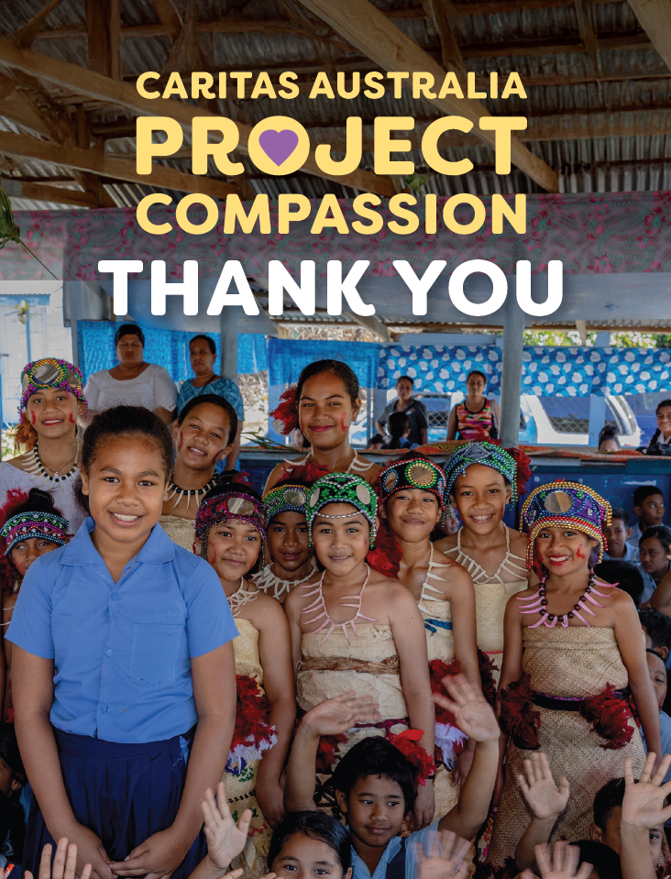
It’s not too late to donate.
You can support Project Compassion 2025 through the donation boxes, envelopes or by scanning the QR code above.
Or online at: caritas.org.au/project-compassion
Or by calling: 1800 024 413

Easter Sunday
20th April 2025

Happy Easter from all of us here at Caritas Australia!
As we celebrate this season of hope and renewal, we want to express our heartfelt gratitude for your support through Caritas Australia’s Project Compassion this Lent.
As we reflect on the Easter message of love, compassion, and new beginnings, we are reminded of the incredible impact your contributions make. Together, we are building a world where no one is left behind.
Thank you for standing with us, as we Unite Against Poverty through Caritas Australia’s Project Compassion 2025 Lenten appeal.

It’s not too late to donate.
You can support Project Compassion 2025 through the donation boxes, envelopes or by scanning the QR code above.
Or online at: caritas.org.au/project-compassion
Or by calling: 1800 024 413
Thank you for standing with us, as we Unite Against Poverty this Lent.

