PROJECT COMPASSION 2021
School Newsletter Notices

We encourage schools to include information about Project Compassion in their weekly newsletter and daily bulletins. In addition to these short newsletter notices, we have written reflections linking the Sunday scripture readings with the stories featured each week during Lent.
You can download the weekly reflections from our Project Compassion website: lent.caritas.org.au
If you would like any other information, logos or photos, please email us: education@caritas.org.au

Ash Wednesday – 17th February 2021 (insert into school newsletter week beginning Monday 15th February)  This week the season of Lent begins with Ash Wednesday, which also marks the beginning of the annual Caritas Australia Project Compassion Appeal. Donations to Project Compassion allows Caritas Australia, the Catholic Agency for International Aid and Development, to work with local communities around the world to alleviate poverty, hunger, oppression and injustice.  We encourage you to put your compassion into action this Lent through your prayer, fasting and almsgiving by supporting Project Compassion. Each family will receive a Project Compassion box and/or a set of envelopes for their donations or you can donate online via the Caritas Australia website at: lent.caritas.org.au  Saint Oscar Romero is our inspiration for Project Compassion 2021, so in his words let’s “Aspire not to have more, but to be more.” | 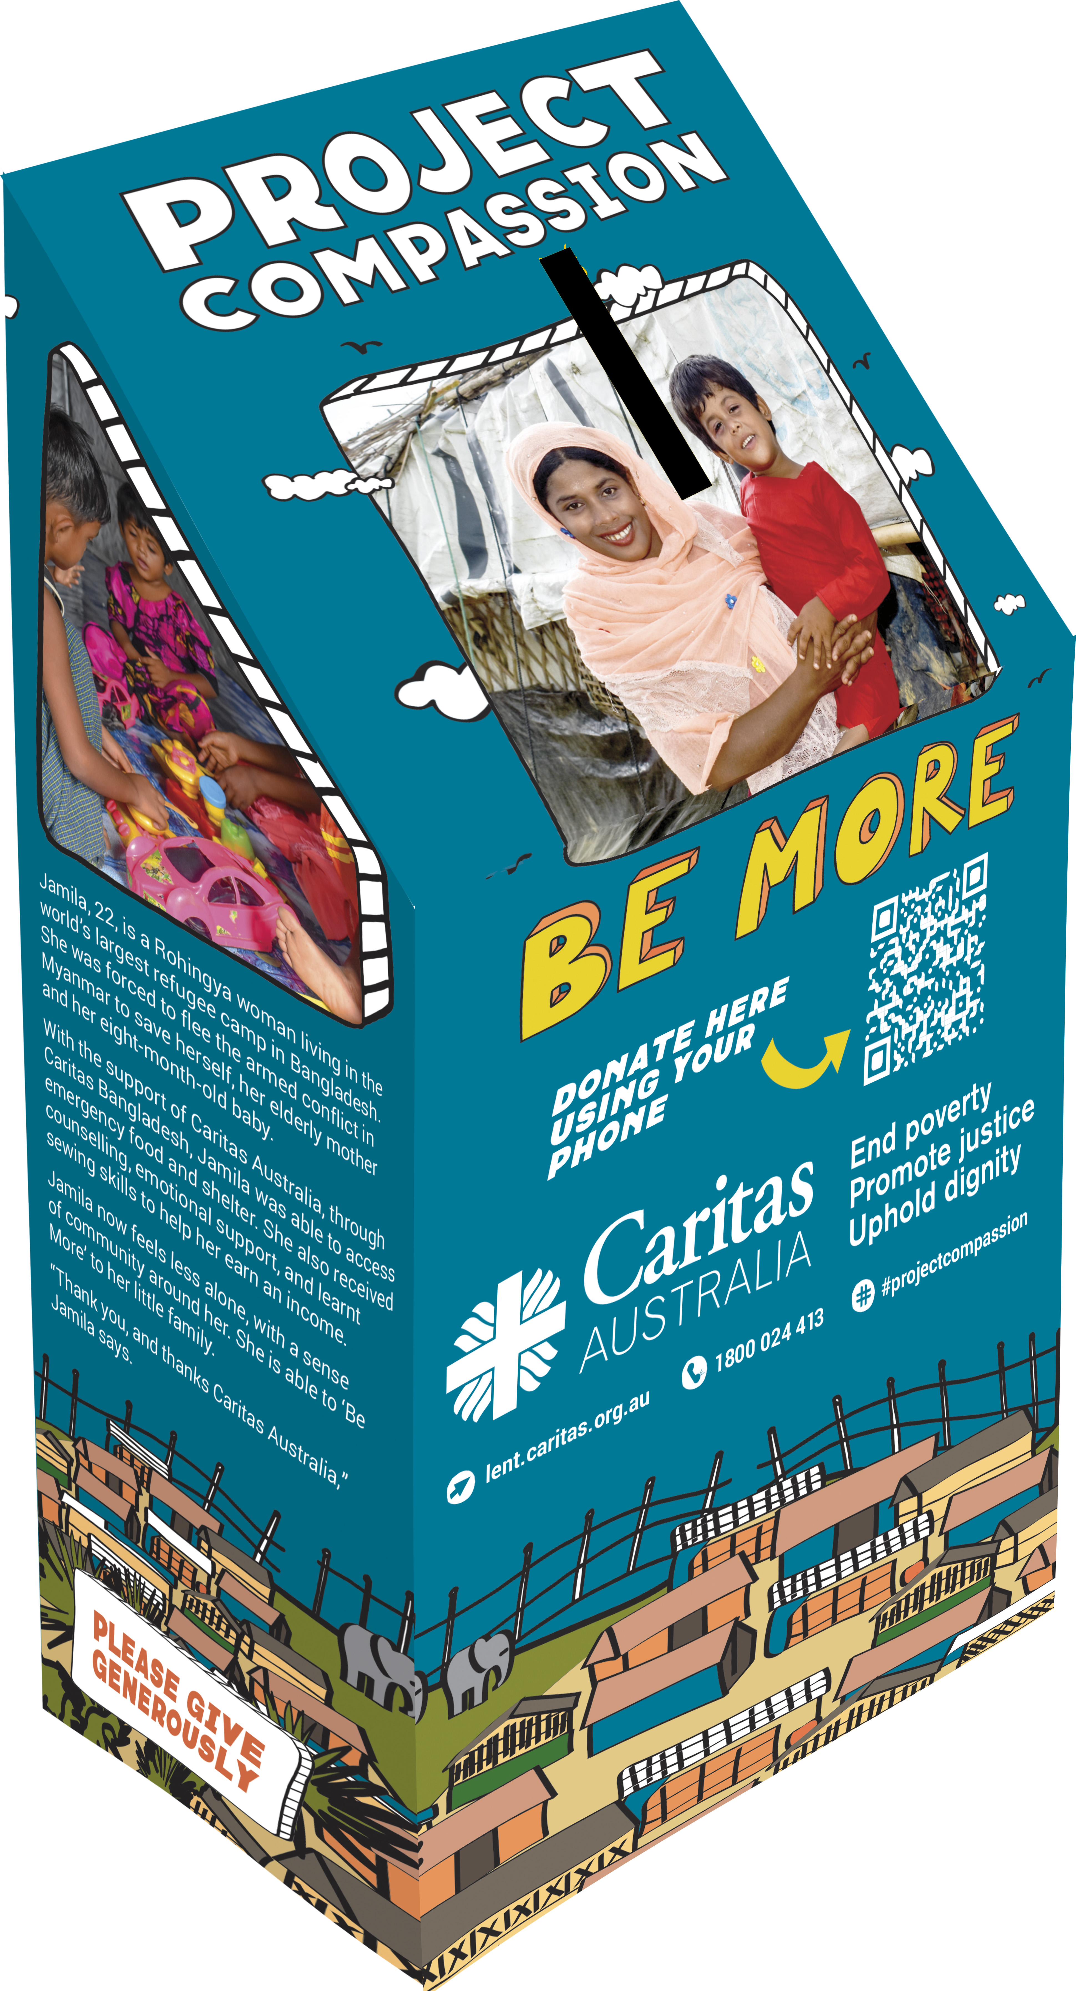
First Week of Lent
(school week beginning Monday 22nd February)
We begin our annual Lenten Project Compassion journey by learning about the story of Jamila and her family. Jamila, 22, is a Rohingya woman, living in the world’s largest refugee camp in Cox’s Bazar, Bangladesh. A single mother, she fled armed conflict in Myanmar to save herself, her elderly mother and eight-month-old baby.
With the support of Caritas Australia, through Caritas Bangladesh, Jamila was able to access emergency food and shelter. She also received counselling, emotional support and learnt sewing skills, to help her earn an income. Jamila now feels less alone, with a sense of community around her. She is able to ‘Be More’ to her little family.
- 860,494 people remain in the densely populated camps, in desperate need of humanitarian assistance, especially due to COVID-19. (UNHCR)
Watch a short film about Jamila’s story here.
“Aspire not to have more, but to be more.” Please support Project Compassion: lent.caritas.org.au

Second Week of Lent
(school week beginning Monday 29th February)
This week through Project Compassion we learn about 39-year-old Margret, a teacher at a vocational school for deaf students in the Solomon Islands. She was born deaf, so she knows the challenges it poses to education and employment. Apart from the difficulties the students all have, the school also faced water shortages, with not enough to supply staff and students with safe water for drinking, cooking, washing and growing vegetables.
Then Tropical Cyclone Harold damaged the school and its vegetable garden, amidst the threat of COVID-19. Staff and students rely on the vegetable garden to provide food for their meals.
With Caritas Australia’s support, the school installed water tanks, provided cyclone-proof building materials and helped to implement COVID-19 prevention measures. Margret’s school now has enough water for its students and the capacity to cater for more, with plans to boost food security, through increased agricultural production.
- Around 60% of people in rural areas in the Solomon Islands don’t have access to piped water, while about 80% don’t have access to latrines or toilets. (UNICEF, 2019)

Watch a short film about Margret’s story here.
“Aspire not to have more, but to be more.” Please support Project Compassion: lent.caritas.org.au

Third Week of Lent
(school week beginning 8th March)
We are now in the third week of Lent with the Project Compassion story of Oliva, a 22-year-old woman from Tanzania. She did not have the opportunity to go to school and was embarrassed that she was unable to read, write or count. As an adult, her business was losing money because she couldn’t add up her money and give the right change to customers.
Then Oliva enrolled in Caritas Australia’s literacy and numeracy classes. She also set up a home classroom to teach her neighbours, for free, because they were too shy to attend larger classes.
Oliva has now graduated, attendance at her classes are growing, her kiosk is thriving and she is helping her children with their homework. She aims to become a pastor and run for leadership in the next local election - to help her community to ‘Be More.’
- Approximately 260 million children don’t have the chance to go to school (un.org)
Watch a short film about Oliva’s story here.
“Aspire not to have more, but to be more.” Please support Project Compassion: lent.caritas.org.au

Fourth Week of Lent
(school week beginning 15th March)
Arsad, an Indonesian farmer, had no toilet in his house, so always had to walk into the forest to the open defecation area. His family was often sick and open defecation caused many neighbourhood disputes. With the support of Caritas Australia and its partner agency, Laz Harfa, Arsad took part in hygiene, sanitation and financial management training. He then funded the building of a toilet in his house and helped other community members to save money to construct their own toilet.
Now, Arsad’s family is healthier, their community no longer practices open defecation and is more harmonious. Arsad inspired his community to ‘Be More.’
- Around 17 percent of Indonesia’s rural population, or 45 million people, practice open defecation – going to the toilet outdoors in fields, forests and other open spaces. (World Bank)

Watch a short film about Arsad’s story here.
“Aspire not to have more, but to be more.” Please support Project Compassion: lent.caritas.org.au

Fifth Week of Lent
(school week beginning 22nd March)
Halima is raising her two children in a refugee camp in Bangladesh, while caring for her mother who has a disability. Widowed at 21, Halima fled violence in Myanmar’s Rakhine State, arriving at the camp with nothing.
Caritas Australia, through Caritas Bangladesh, helped Halima with shelter, cooking equipment, hygiene and sanitation training. She took on the role of community trainer herself, organising the cleaning of washrooms, wells and toilets.
Halima aspired to “Be More” and is proud that she is able to earn a small income, while maintaining the health of her family and the cleanliness of the camp community.
- In the Cox’s Bazar district, women and children make up 78% of the total refugee population where 52% of children are aged 0-17. (UNHCR)

Watch a short film about Halima’s story here.
“Aspire not to have more, but to be more.” Please support Project Compassion: lent.caritas.org.au

HOLY WEEK
(school week beginning 29th March)
As we enter Holy Week, we continue to reflect on the lives of people vulnerable to extreme poverty and injustice and how we can respond through supporting Caritas Australia’s Project Compassion appeal.
Let us take time to remember the life and teachings of Saint Oscar Romero. His many lessons include: live a simple life, commit to bringing peace to the world, speak the truth and of course aspire not to have more, but to be more. Some words from what has become known as the Oscar Romero prayer; “We cannot do everything, and there is a sense of liberation in realizing that. This enables us to do something, and to do it very well. It may be incomplete, but it is a beginning, a step along the way, an opportunity for the Lord’s grace to enter and do the rest.”
Thank you for supporting Caritas Australia’s Project Compassion Campaign. Your generosity will work for the freedom of those living in poverty, challenge unjust structures, and empower people to work for a sustainable way of life.
Please return all Project Compassion boxes and envelopes to the school office by Friday 28th May or donate online via the Caritas website at lent.caritas.org.au

